Parent Workshop
Enhancing reading with your children.

Why do we read with our children?
What does my child do in school to support their reading?
What types of reading are there?
What is it that makes a ‘good reader’?
How can we be better at ‘hearing’ children read?
What can I read with my children?

KS1

English at Longton Primary School:

At Longton Primary School we aim to help children to develop a love of the English Language through the spoken and written word. We believe that being literate is not just an and in itself but a means of providing the key to unlock all other areas of learning and thus enabling all children to take a full and constructively critical part in society, empowering them aesthetically, socially, spiritually and morally. We will resect and build on the diversity of pupil’s language, literacy experiences and cultures, preparing them for the daily demands of spoken language and print, in a fast changing society. We recognise that English is a core subject within the National Curriculum and a pre – requisite for educational and social progress.

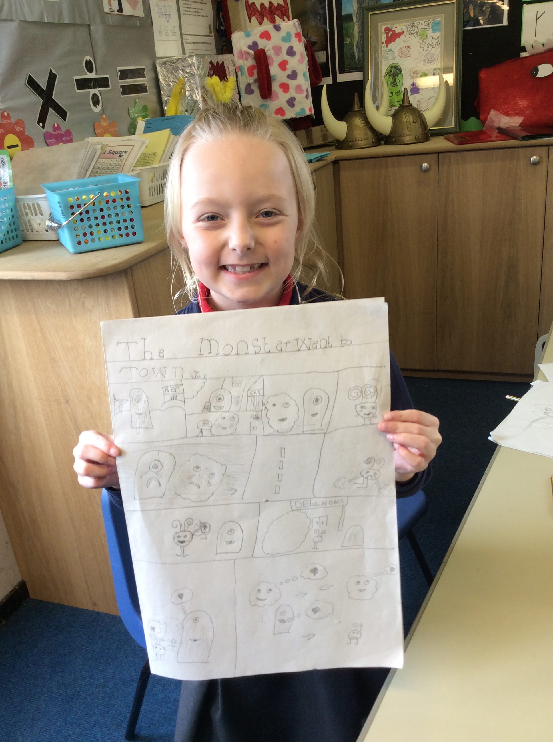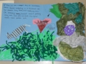

Philosophy:

Reading at Longton Primary School

Studies show that reading a variety of literature independently by the age of 15 is the single biggest indicator of future success, outweighing negative factors such as socioeconomic background or family situation.

At Longton Primary School, we believe that reading is part of the total development of the child on the path to being a literate adult. We believe that reading should encourage a positive view of the written text as a source of pleasure as well as a valuable source of ideas and information to support all areas of the curriculum.

Aims for Reading at Longton Primary School:

To foster a love of books and an interest in reading and the ability to evaluate and justify their preferences.
To provide opportunity for shared, guided and independent reading.
To develop a range of reading cues (phonic, graphic, syntactic and contextual) to monitor their reading and correct their own mistakes.
To foster an interest in words and their meaning, and to develop a growing vocabulary.
To encourage children to read with confidence, expression, fluency and understanding.
To provide a wealth and variety of reading material in a range of form, genre, non-fiction and poetry by a variety of authors and from different cultures, styles, formats, myths, legends, traditional stories, dictionaries, thesauruses and encyclopaedias.
To provide reading material which reflect the equal opportunities policy of the school.
To encourage reading skills in all areas of the curriculum. To develop skills of information retrieval.

Fewer than half of 8 to 16 year olds have read a book in the last month.

49% of children and young people think that reading is boring.

Children who enjoy reading very much are five times more likely to be above average readers.

36% of teachers cannot name
six children’s authors.

To identify and meet the special educational needs of some children enabling them to have full access to the curriculum.
To teach the care and respect of books.
To encourage parental involvement in reading by supporting the school reading system and visiting local libraries. To use I.C.T. as a reading resource.
To regularly assess individual reading skills to ensure progression. To keep and maintain accurate reading records.
To provide a stimulating reading environment within the classroom and school by attractively displaying books and neatly labelling children’s work and displays.
Implementation:

Each child’s reading/comprehension level will be assessed on entry to the school and the appropriate reading material provided accordingly.
Children who are not ready to read will begin pre-reading activities at an appropriate level for their individual stage of development. Teachers and other adults (TA, voluntary helpers) will continue to hear children read on an individual basis. Frequency of hearing children read, will be at the discretion of the teacher. KS2 children will do daily reading response activities, one of which will be done with the class teacher. In KS1 the children have a weekly guided reading session in small groups.
Shared reading is part of the Literacy Hour and each year band has a number of Big Books and suitable texts.

Opportunity for the teaching of reading will also take place within the Longton Curriculum.
All reading material is colour coded into ability levels.
Free reading begins after Magenta Band level. The children may select any book from the school library or home and from named authors, poetry and fiction. This may need some teacher guidance. The children will experience parallel reading of their own choice (fiction, non-fiction and poetry) at all levels to increase confidence and to ensure that the children can recognise new vocabulary in any situation.
It is important that the children do not progress to the next reading level until they are fluent and confident. ‘Repetition through variety to consolidate’.
It is also important that children do not transfer reading levels at the end of the Summer Term as some children’s reading regresses during the summer holiday. It can then be a positive step for the child’s new teacher to move the child up a reading level when they start a new class in the autumn term.
Reading is for meaning and not merely decoding and therefore comprehension should also be taken into account before transferring levels. There is no point in pushing a child through the levels if they need consolidation. Each child will need to consolidate at some point.

How Hard Should Reading Be?

There are 3 levels of reading fluency. Children should experience reading at Independent and Instructional Level but never at Frustration level.

Independent (1%) - Child reading without adult/peer support and only experiencing difficulty with 1 word in 100 (does not know word or substitutes an inappropriate word when reading)

Instructional (5%) - Child reading with adult/peer support and experiencing difficulty with 5 words in 100.

Frustration (10%) - Child experiencing difficulty with 10 words in 100 (Comprehension is estimated to be below 50% at this level).

Records:
22% of children report that no one at home encourages them to read.

Reading books will be sent home as outlined on each classes termly curriculum outline.

A daily record of what children have read should be made in the blue reading record

Reading expectations

EYFS | Reading 3 times a week.
YEAR1 | Reading 3 times a week
YEAR2 | Read 4 times per week for 15 minutes
YEAR3 | Read 4 times a week.
YEAR4 | Read 4 times a week.
YEAR5 | Read 4 times a week.
YEAR6 | Read daily.

Listening to Children Read: Some Useful Advice.

- Talk with children about the book they are reading.
  - What is it about?
  - Do they like it?
  - What has happened so far?
  - What do they think will happen next?

- With less able readers, talk about the pictures. Pictures help children to understand the words.
  - What does this picture tell you?
  - What can you see happening in the picture?
  - What do you think is going to happen?

- With more able readers, discuss the characters and the words and phrases used by the author.
  - What does that word mean?
  - What do you think the author means by that?
  - Why have the words been written in this way?

- When a child doesn't know a word, ask him or her to have a go, then tell the child what it is.

- If a child misreads a word, stop him or her and say the correct word - although if it is a word which makes no difference to the meaning (a positive miscue), for example 'home' instead of 'house' or 'water' instead of 'sea', it is usually best to ignore it.

- Use lots of praise and encouragement, and avoid criticism. It is important that the children become more confident with reading.

- Don't make children read for longer than they can keep their interest and attention on the task.

- Do talk about the book after reading (not as a test, just as a chat).

- Do show patience, progress can be slow.

- Let them see you, and join you, reading for a purpose: TV, magazines, letters, instructions, charts, signs etc.

- Stop reading rather than read when tempers are fraying. Come back to the book another time.

Golden Rules for Reading

DO settle in a quiet, comfortable space together, ensuring you can both see the book and your child is holding the book themselves.

DON’T think that because your child can make his or her way through simple school reading books without too many mistakes that he has mastered reading. Fluent, confident and perceptive reading will take years of practise.

DO find things for your child to read which centre on their non-school interests. Try to help your child to understand that reading is something we do for fun and not just at school.

DON’T think that books are the only or best way to practise reading. Comics, magazines and some websites are also great ways for your child to get enjoyable reading practice.

DO let your child see you reading for enjoyment from time to time. It is true that children do as we do, not as we say.

DO read some of the same things that your child reads. It’s nice to be able to talk to someone else about what we’ve read.

DON’T criticise or pressurise your child if they’re not that keen on reading. Instead try to find reading material about their hobbies or interests which might encourage a reading habit. But if they’re still not interested take a step back for a little while.

DO encourage your child to lend books or comics to friends and let them borrow them from others. This might spur them on to reading even more, and it helps to keep your costs down!

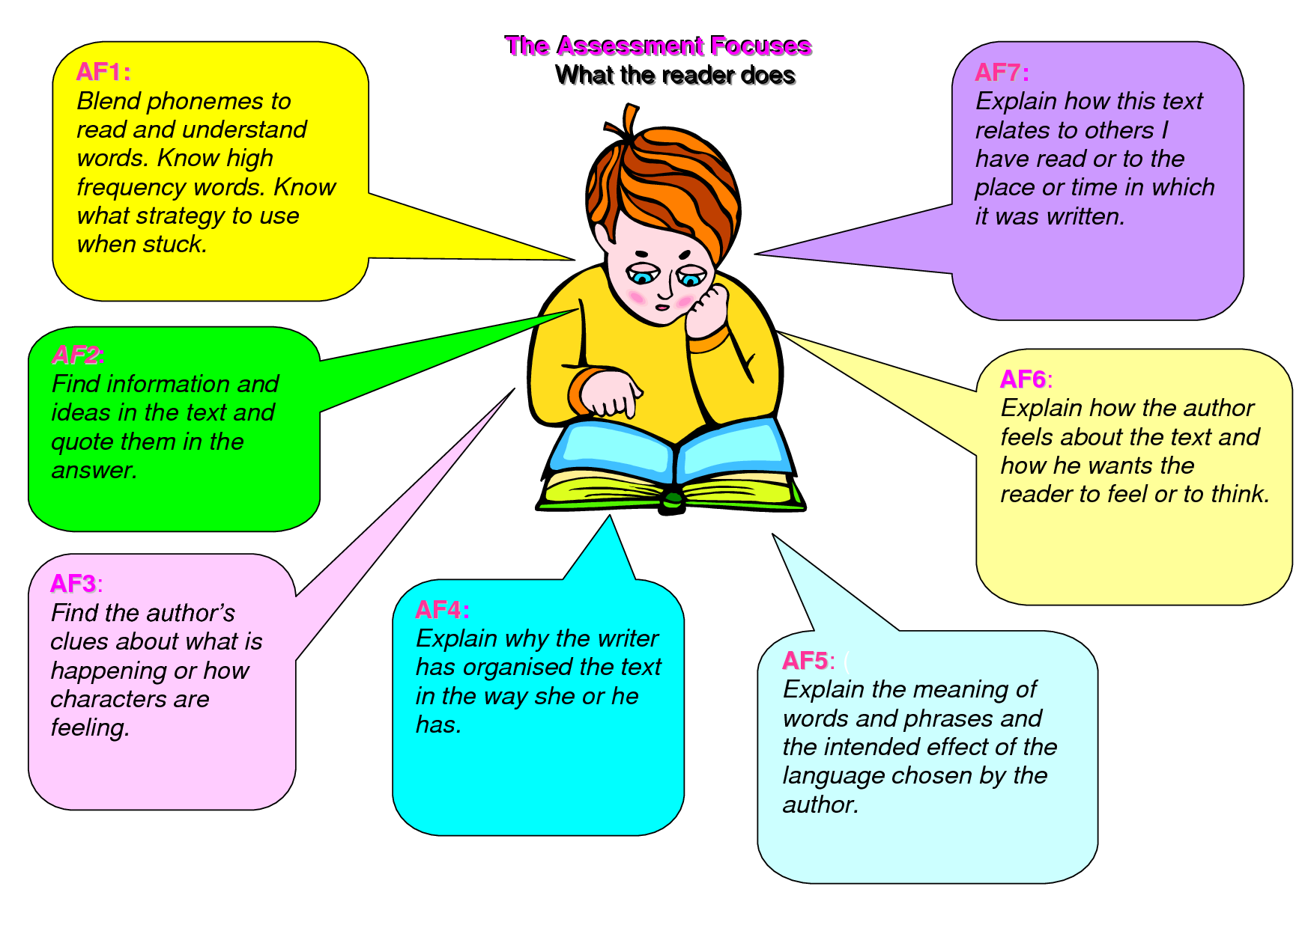

Enhancing Reading with your Children

Effective reading is so much more than simply “hearing” your child read. Whilst this has its place, as can be seen in the “elements of reading” (see previous page), children need to acquire a vast range of skills to become competent and confident readers. Children therefore need to be supported in making progress in these seven key areas of skill through:

Quality reading time,
with an adult who is willing to:
- discuss,
- interrogate,
- seek clarification and
- enjoy the many elements of ‘a good read’ with their child.

On the following three pages are questions linked to each of the ‘elements of reading’. Use these questions selectively to enhance your quality reading time with your child.

Very best wishes for lots of enjoyable reading.

Learning to Read
- Reading skills are like building blocks. To learn to read well, children need the blocks of knowing the sounds of letters (phonics) and the blocks of knowing the meanings of words (vocabulary), word parts (grammatical markers) and groups of words (overall meaning or semantics). To build these foundations of reading, children need effective reading instruction.
- Interesting article ‘How do children learn to read’ at www. reading rockets.org

Phonics and Early Reading

- Learn and introduce new sounds in line with Letters and Sounds and the New National Curriculum..
- Practise knowing the sounds they make.
- Apply the sounds knowledge to reading and writing words.
- Learn spellings with phonic patterns.

What this Looks Like

- Introduce new sounds starting with s, a, t and p.
- Learn the names and the sounds the letters make.
- Practise blending these letters to make words.
- Practise using these letters to make words.
- Practise letter formation (small and capital).
- Continual practise recognising, reading, word building and letter formation with new sounds.
- Apply knowledge in word games and in sentences.

Phonics are Essential for Blending Words
sh - o - p = shop
l - ou - d = loud
c - l - ow - n = clown

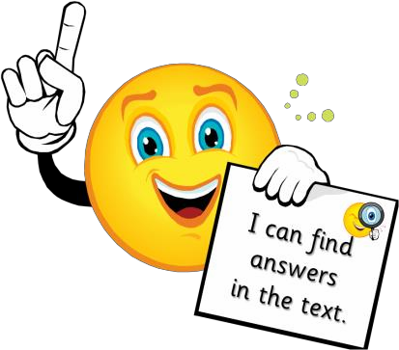

Elements of Reading | Potential Questions to Support in the Element’s Development
AF2 - Understand, describe, select or retrieve information, events or ideas from texts and use quotation and reference to text. | - Where does the story take place?  - When did the story take place?  - What did he/she look like?  - Where did he/she live?  - Who are the key characters in the book?  - What happened in the story?  - What kinds of people are in the story?  - What is happening at this point in the story?  - Read the part that tells me………  - Where did you find the information about…..?
AF3 - Deduce, infer or interpet information, events or ideas from text.  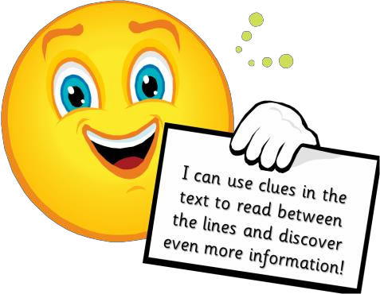 | - What makes you think that?  - What words give you that impression? Why?  - How do you feel about………? Why?  - Can you explain why………….?  - If you were going to interview this character/author, which questions would you ask?  - Which parts of the book could help you find the information you need?  - Do you agree with this opinion? Explain your own opinion using the texts to help you?  - At the end of the story the main character is feeling ……. Does this surprise you? Explain as fully as you can using parts of the story to help you?  - What does this tell you about what ……….was thinking?  - Through whose eyes is the story told?  - Who was the storyteller? How do you know?  - Do you think this is true/untrue? Why do you think this?  - What do you think the ………. is thinking?  - Which is your favourite part? Why?  - Predict what you think is going to happen next. Why do you think this?  - Using all the evidence available, can you tell me what you feel about….?  - Who would you like to meet most in the story? Why?  - Can you support your view with evidence?  - Is this a place you could/would visit? Why/why not?

AF4 - Identify and comment on the structure and organisation of texts, including grammatical and presentational features at text level.  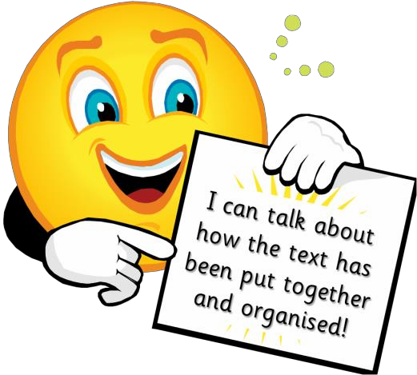 | - Were you surprised by the ending?  - How did you think it would end/should have ended?  - How are the beginning and ending of the story similar?  - What kind of a text is this? How do you know? What will it be like? What can I expect of a book of this type?  - List the words that tell you what order to follow e.g. first, then.  - What is the main event of the story? Why do you think this?  - What is the purpose of the pictures?  - How does the layout help the reader?  - Some of the text is printed on a dark background. What effect do you think the designer wanted to achieve by doing this?  - How does the way the title is written encourage you to read the ……….?  - How do you know the order to follow the information in the text?  - Why have these words been made to stand out?  - At the end of the story the author leaves you guessing about what will happen next. What do you think will happen next? Why do you think this?  - Why is this paragraph in bold print?  - What are the subheadings for?  - Why has some of the information been presented as a table?  - What is the purpose of the writing in the boxes?  - What do the arrows show you about the structure of the text?
AF5 - Explain and comment on the writers’ uses of language, including grammatical and literary features at word and sentence level.  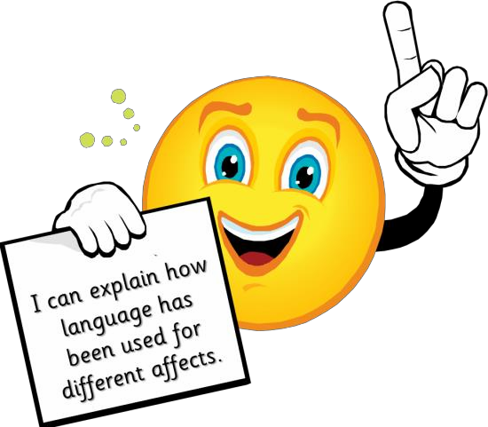 | - What do these words mean and why do you think the writer chose them?  - How has the author used adjectives to make this character funny?  - What do the physical descriptions of characters tell us about how they are feeling?  - Look at the verbs/adjectives/adverbs, what do these words tell us about…………?  - What do these words tell you about ………?  - What does the word ................. tell you about the way the character moved/felt etc?  - Why do you think the author has mentioned ……… a lot in the story?  - Why did the author choose this title?  - What is the effect of writing in the past/present tense?  - Why do you think the writer has chosen to use the words ……………………..?  - Why do you think the author has written this sentence in this way?  - Do you want to read the rest of the text? How does the writer encourage you to read the rest of the text?  - How do these phrases help to make the description effective?  - How does the author make the …………… appear frightening?  - Which part of the story best describes the setting?

AF6 - Identify and comment on writers’ purposes and viewpoints and the overall effect of the text to the reader.  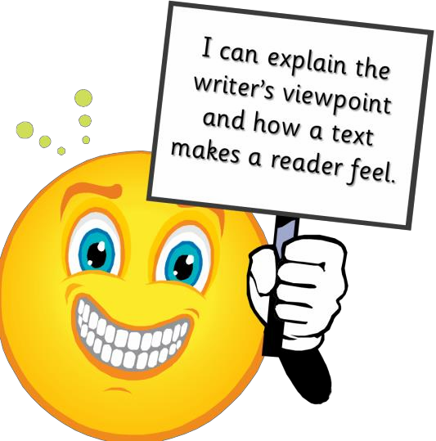 | - Can you think of another story that has a similar theme e.g. good over evil, weak over strong, wise over foolish?  - I wonder why the writer has decided to…?  - What was in the author’s mind when he wrote this?  - Why did the author choose this setting?  - How would the views put across in these texts affect your views on….?  - What makes this a successful story? What evidence do you have to justify your opinion?  - Could it be better? Is it as good as…..?  - What effect does it have on you as a reader?  - Why do you think the writer wrote that description?  - What was the most exciting part of the story? Explain your answer as fully as you can!  - Which illustrations did you find most useful?  - What are the main contrasts the poet makes in the third and first parts of the poem?  - What impression of ………..does the first paragraph give you? In what ways is the second paragraph different?  - The text try to make you care about …………… Do you think it is effective? Why?  - What is the author’s opinion about …………….?
AF7 - Relate texts to their social, cultural and historical contexts and literary traditions. | - Do you know another story, which deals with the same issues eg social, cultural, moral issues?  - What would this character think about…….? (Possibly a present day issue)  - Do you know any more stories like this?  - Have you ever read a book with a similar theme to this one?  - Does this story remind you of any personal experience/something that has happened to you? Describe it.  - Have you ever been in that situation? What happened?  - How would you have felt in the same situation?  - What might you have done instead?  - How would you feel if you were treated like ……….? What would you do?  - What do you think would have happened if…………?  - What kind of a text is this? How do you know? What will it be like? What can I expect of a book of this type?  - Many traditional tales have messages. What do you think this story is trying to tell us?  - Which stories have openings like this?  - Do you know any other texts with similar issues or themes?  - Do you know another story with these characters in?  - Can you think of another story where the main character has problems with their family?

