Ten Ideas for Phonics at Home
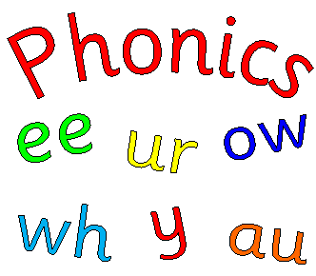
- I-Spy – guess what your child is looking at from the first sound.
- Swat the sounds – hit sounds with a fly swat (or something else that isn’t dangerous!).
- Hunt the sounds - hide sounds round the house for children to find (balls, pebbles, pegs, post-its).
- Air-write – write the sound in the air or on your partner’s back.
- Glitter writing – write sounds in glitter (or sand) using a paintbrush (a little messy!).
- Magnetic letters – arrange magnetic letters on the fridge to make sounds and words.
- Giant writing – write sounds in chalk or on large rolls of paper.
- Sound boxes – gather selections of items that all begin with the same sound.
- Lollypop teacher – children use a lollypop to point to sounds and test you.
- Online games – phonicsplay.co.uk (N.B. some games require subscription).

