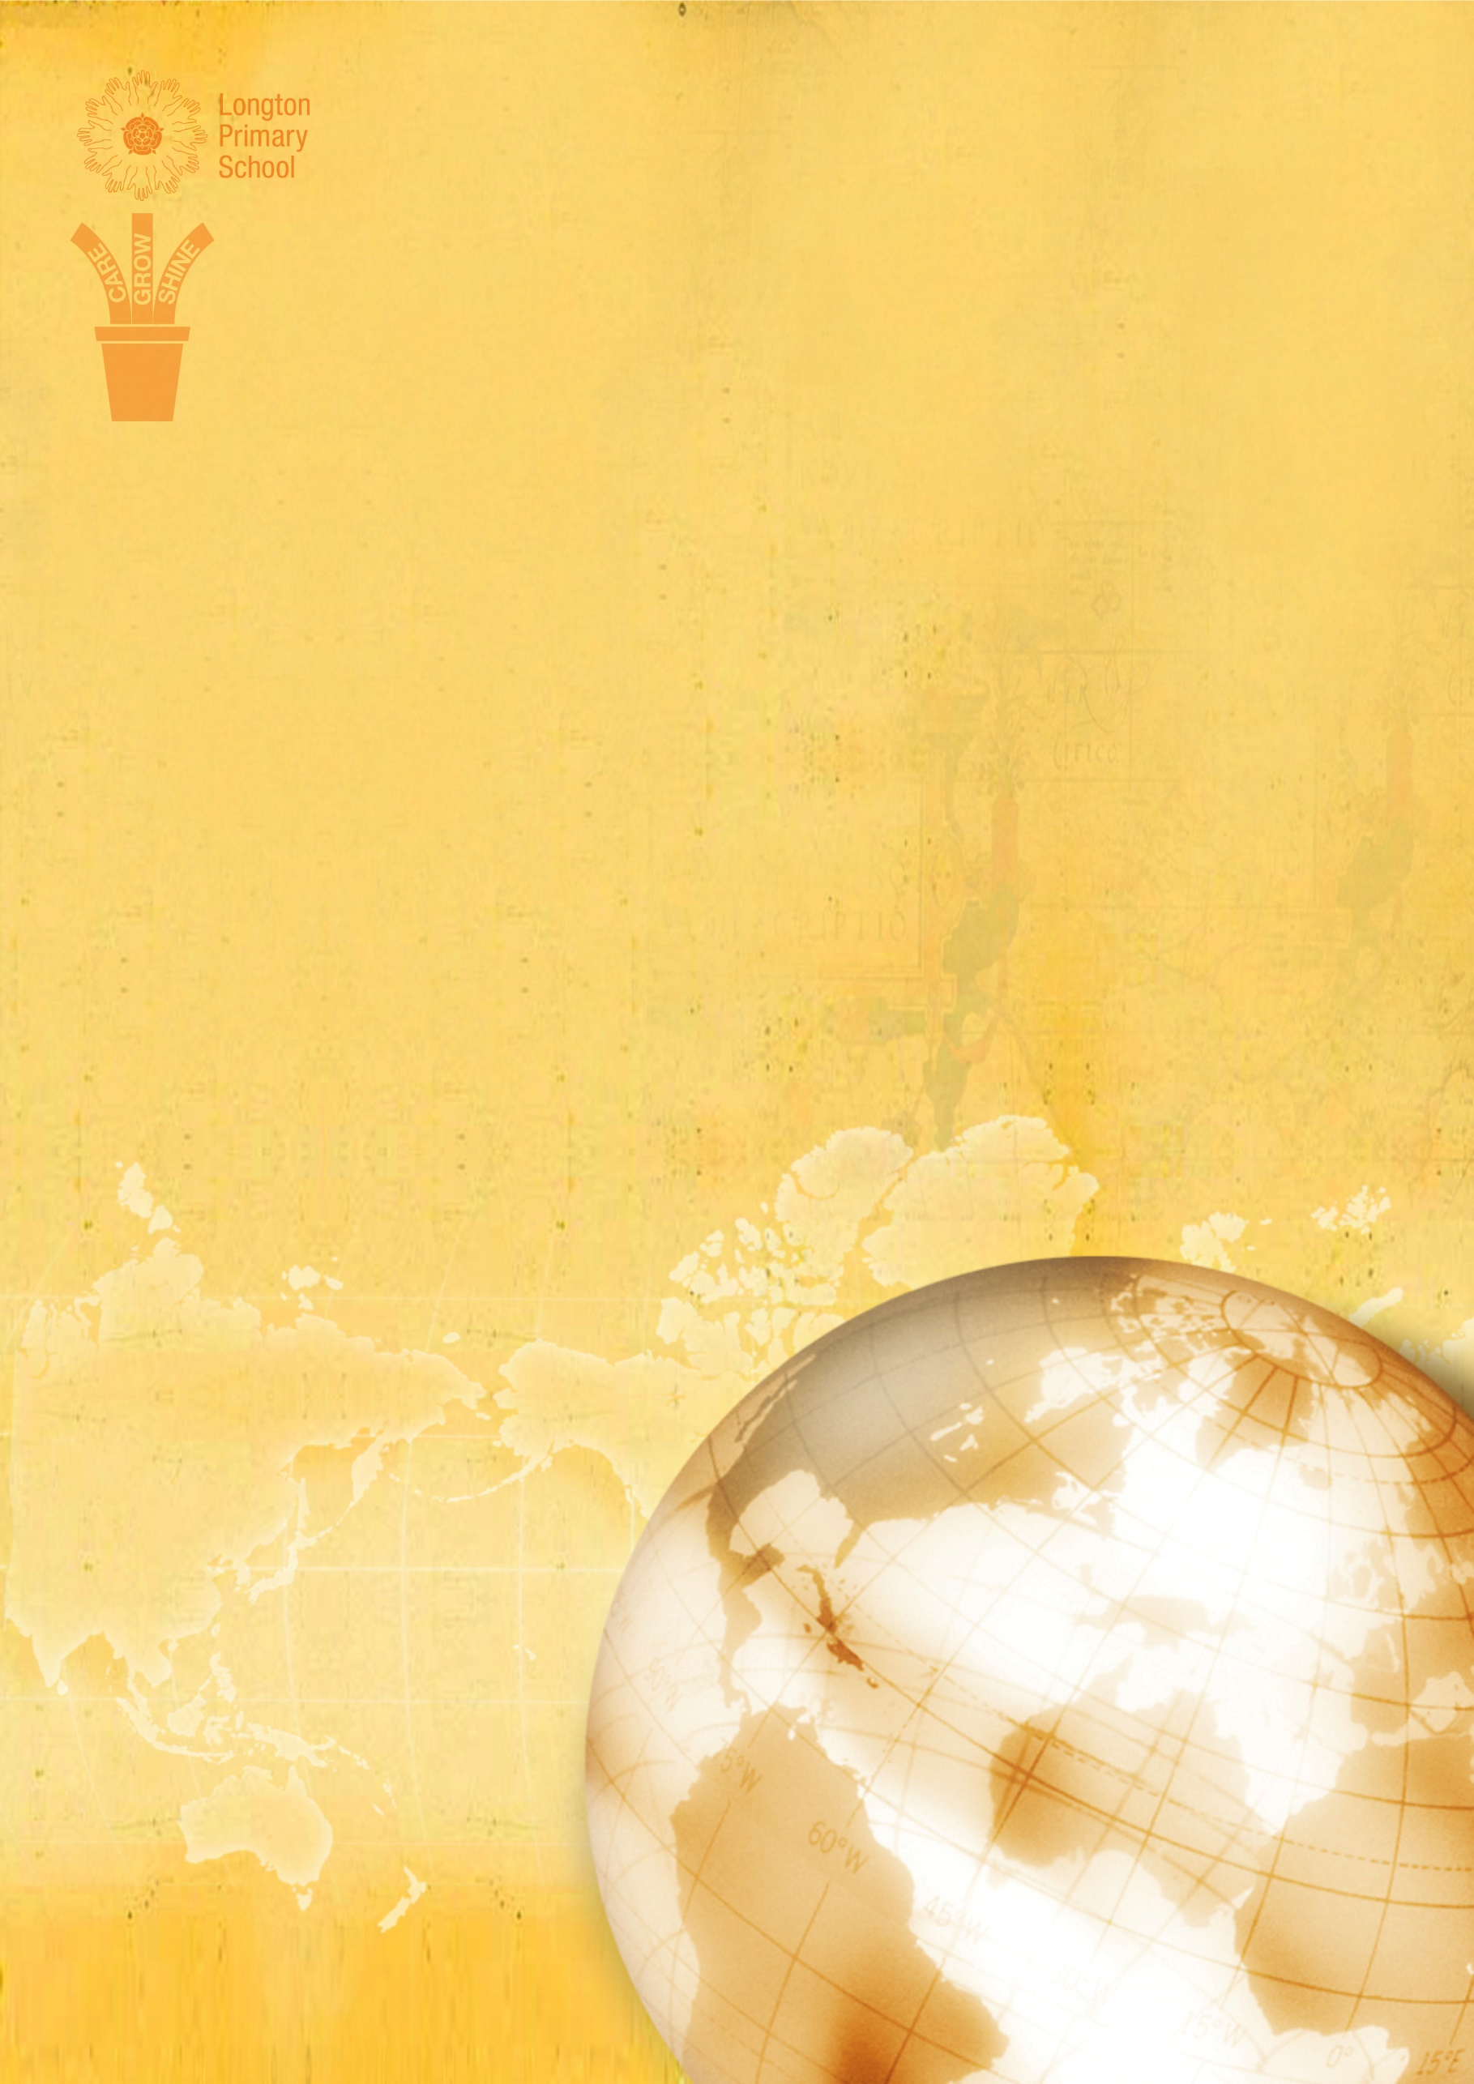
Relationships and Sex Education Policy

In caring about excellence and each other, and in promoting enjoyment and happiness through fulfilment, the members of Longton Primary School community believe in

CARE through respect, support and togetherness
GROW through choice, opportunity and imagination
SHINE through challenge, achievement and celebration

Relationships and Sex Education Policy
Longton Primary School

Introduction
At Longton Primary School we believe that the area of Sex and Relationships is an integral aspect of our personal, social, moral and health development of the children in our care and that they are entitled to this as part of a broad and balanced curriculum.

The policy has been developed to ensure that staff and parents/carers are clear about the statutory requirements regarding Relationships and Sex Education, and that the pupils receive their educational entitlement giving due consideration to DfE Sex and Relationships Guidance (2000) and the guidance provided by the PSHE Association in Sex and Relationships Education for the 21st Century (2014). We have also taken into account the recent announcements by the DfE in Sex and Relationships Education in Schools (England) (March 2017).

The teaching of Relationships and Sex Education at Longton Primary School uses an integrated and consistent approach through the use of our PSHE curriculum Jigsaw. Relationships and Sex Education includes supporting our pupils in developing self-confidence in preparing for physical and emotional changes into adulthood. We believe that the teaching of Relationships and Sex Education should be shared with parents and be mutually supportive and complementary. It promotes an understanding of the range of family types and other people who contribute to providing children with the care, love and support they need to grow and develop.

In this document, Relationships and Sex Education relates to ‘learning about physical, moral and emotional development’. It is about understanding the importance of family life, stable and loving relationships, respect, self-esteem, love and care and promoting the British Value of tolerance.

Every child is entitled to receive Relationships and Sex Education where the well-being of the learner is paramount. It is our intention that all children have the opportunity to experience a programme of Relationships and Sex Education at a level which is appropriate for their age and physical development with differentiated provision if required. We firmly believe this is paramount for teaching pupils the skills and knowledge to safeguard themselves, and prepare children for the challenges, opportunities and responsibilities of adult life, building healthy relationships and staying safe.

The Moral and Values Framework
Sex and Relationships Education is lifelong learning about physical, moral and emotional development. It is about understanding the importance of marriage for family life; stable and loving relationships, respect, love and care. It is also about the teaching of sex, sexuality and sexual health. It is not about the promotion of sexual orientation or sexual activity.” (DFE July 2000)

Relationships and Sex Education is required to be taught within a moral framework of mutual respect, rights and responsibilities, gender equality and acceptance of diversity. Children will learn about moral values through all aspects of school life and through a variety of curriculum areas, not just in Relationships and Sex Education.

We aim to:
• Help pupils develop sensitivity and respect for themselves and others.
• Provide a friendly and caring environment in which children are able to ask questions and further their understanding.
• Support pupils in taking responsibility for their actions and the consequences of their actions.
• Provide equality of opportunity for all children in a caring community in which each individual is encouraged to make a valuable contribution.

Overall Aims and Objectives
We aim to achieve this by:
• Providing PSHE Education that is dynamic, relevant and appropriate for the challenges and contexts of 21st century life as part of our commitment to broad outcomes for children.
• Holding high expectations for all and modelling our expectations at all times.
• Viewing Relationships and Sex Education as vital and a holistic part of our duty to safeguarding and child protection and the promotion of outstanding behaviour.
• Teaching children about equality and diversity as is our duty within the Equalities Act (2010) through dealing honestly and sensitively with sexual orientation, answering appropriate questions and offering support, without direct promotion of any orientation.
• Providing our pupils with Relationships and Sex Education that is age appropriate and contributes to lifelong learning and pupil well-being.
• Having a strong commitment to confidentiality and to providing a safe learning environment where all feel respected whilst safeguarding vulnerable pupils.
• Informing and working with parents and families to support and promote our work in school by making policies and schemes of work available in school and on our website and supporting them should they have questions or concerns about RSE.
• Involving our local community partners such as healthcare professionals to enrich and support pupil’s learning in Relationships and Sex education where appropriate.

Aims of Relationship and Sex Education
Taking account of the age, maturity and needs of the pupils, Relationships and Sex Education aims:
- To provide the knowledge and information to which all pupils are entitled regarding their changing bodies, including reproduction and the importance of health and hygiene.
- To nurture self- esteem, self-confidence and emotional development.
- To promote self value and learn respect for themselves and others.
- To prepare pupils for puberty and reduce anxiety about growing up.
- To develop skills in decision making, communication, assertiveness – encourage them to take responsibility for their own actions.
- To protect them from harm/exploitation.
- The overall aim is for the children to develop the skills and understanding they need to live confident, healthy independent lives and to deal with difficult moral and social questions.

Confidentiality
At Longton Primary School we believe that because Relationship and Sex education works within pupils’ real life experiences, it is essential to establish a safe learning environment. We will create a safe and supportive learning environment by:
• Establishing ground rules for lessons.
• Role modelling and teaching our high expectations of behaviour for learning.
The children will be made aware of the boundaries of confidence at the start of each lesson as part of the ground rules.
• Sharing the need for confidentiality with staff and pupils and being clear about procedures should pupils indicate that they are vulnerable or “at risk” through our Confidentiality and Safeguarding Policies.

Where pupils indicate that they may be vulnerable and at risk, they will get support by staff following our Safeguarding Policies and informing the Safeguarding Leads.

Equality and Diversity
Our school strives for the best outcomes for all pupils irrespective of disability, educational needs, race, nationality, ethnic or national origin, sex, gender identity, religion or sexual orientation. We ensure our Relationships and Sex education is sensitive to the needs of ALL our pupils and their families by:
• Being aware of each group of pupils’ individual characteristics, backgrounds, attitudes and feelings.
• Differentiating teaching and learning from our planned scheme of work to allow access to Relationships and Sex education for all our pupils including those with SEND or EAL.
• Valuing and respecting all pupils and adults contributions and experiences by supporting them to articulate their perceptions.
• Ensuring freedom from all forms of bullying including homophobic, biphobic, and transphobic bullying as is our duty within the Equalities Act (2010) through a zero tolerance approach within all our policies and practice.
• Promoting social learning and expecting pupils to show a high regard for the needs of others by following our Learner Values of Respect, Responsibility, Role-Modelling, Resilience, Ambition and Teamwork.

Key Principles and Teaching Methodology
Our programme of study is taught through a core scheme (Jigsaw) which is approved by the PSHE Association and follows the strands and themes outlined by them and the DfE’s non-statutory and statutory guidance. The specific RSE content is taught through the Changing Me puzzle of learning in each year group. The resources include picture cards, resource sheets and animations of the female and male reproductive systems which provide a visual resource to enable pupils to understand how the body changes and develops during puberty. Whilst the core RSE content is delivered through the Changing Me puzzle essential work is done in previous puzzles to build children’s self-esteem, to enhance sense of self in regard to body image, how to develop caring and healthy relationships and how to develop assertiveness skills in keeping themselves values, safe and respected. This work underpins the explicit RSE content and is part of the holistic approach to RSE teaching and learning.
The programme is taught through a range of teaching methods with an emphasis on active engagement of pupils giving them opportunities to clarify their values and beliefs and rehearse and develop enquiry and interpersonal skills.
Learning in Relationship and Sex education will follow our Teaching and Learning policies.
We aim to give our pupils a comprehensive, balanced and relevant body of factual information to inform their present and future risk assessment, decision-making and management with teachers frequently acting as facilitators.
Pupils will also follow cross curricular learning in National Curriculum subjects that will build on and inform their learning from Relationships and Sex education i.e. Religious Education and Science.
During Key Stages 1 and 2, learners gradually build on the skills, attitudes and values, knowledge and understanding they have started to acquire and develop during the Early Years/Foundation Stage. Relationships and Sex education offers learning opportunities and experiences which reflect the increasing independence and physical and social awareness of learners as they move through the primary phase. They learn skills to develop effective relationships, assume greater personal responsibility and keep themselves safe. In the early primary school years, education about relationships needs to focus on friendship, bullying and the building of self-esteem.
Our teaching and learning in RSE compliments and enhances the statutory content such as where both boys and girls need to know about puberty and how a baby is born – as set out in Key Stages 1 and 2 of the National Science Curriculum.

Key Stage 1
• Notice that animals, including humans, have offspring which grow into adults.

Key Stage 2
• Describe the differences in the life cycles of a mammal, an amphibian, an insect and a bird
• Describe the life process of reproduction in some plants and animals.
• Describe the changes as humans develop to old age.
• Recognise that living things produce offspring of the same kind, but normally offspring vary and are not identical to their parents.
(Parents do not have the right to withdraw their child/children from these above aspects of the Science curriculum.)

All children, including those who develop earlier than the average, need to know about puberty before they experience the onset of physical changes. Relationships and Sex education assists pupils to cope with the changes at puberty, introduces them to a wider world and enables them to make an active contribution to their communities.
The learning intentions for the theme ‘Changing Me’ for each year group are shown below

Year Group | Lesson focus | Learning Intentions ‘Pupils will be able to...’
R |  | identify they have changed since they were babies
1 | Boys’ and Girls’ Bodies | identify the parts of the body that make boys different to girls and use the correct names for these: penis, testicles, vagina. (We will acknowledge that at home you may also have other names for these parts of the body).  respect their body and understand which parts are private.  (Please see the NSPCC website for more information on the PANTS Rule)
2 | Boys’ and Girls’ Bodies | recognise the physical differences between boys and girls, use the correct names for parts of the body (penis, testicles, vagina) and appreciate that some parts of their body are private. (PANTS rule)  tell you what they like/don’t like about being a boy/girl
3 | How Babies Grow | understand that in animals and humans lots of changes happen between conception and growing up, and that usually it is the female who has the baby  express how I feel when I see babies or baby animals
 | Babies | understand how babies grow and develop in the mother’s uterus and understand what a baby needs to live and grow  express how I might feel if I had a new baby in my family
 | Outside Body Changes | understand that boys’ and girls’ bodies need to change so that when they grow up their bodies can make babies  identify how boys’ and girls’ bodies change on the outside during this growing up process  recognise how I feel about these changes happening to me and know how to cope with those feelings
4 | Inside Body Changes | identify how boys’ and girls’ bodies change on the inside during the growing up process and why these changes are necessary so that their bodies can make babies when they grow up  recognise how I feel about these changes happening to me and how to cope with these feelings
 | Having A Baby | correctly label the internal and external parts of male and female bodies that are necessary for making a baby  understand that having a baby is a personal choice and express how I feel about having children when I am an adult
 | Girls and Puberty | describe how a girl’s body changes in order for her to be able to have babies when she is an adult, and that menstruation (having periods) is a natural part of this  know that I have strategies to help me cope with the physical and emotional changes I will experience during puberty
5 | Puberty for Girls | explain how a girl’s body changes during puberty and understand the importance of looking after myself physically and emotionally  understand that puberty is a natural process that happens to everybody and that it will be OK for me
 | Puberty for Boys and Girls | describe how boys’ and girls’ bodies change during puberty  express how I feel about the changes that will happen to me during puberty
 | Conception | understand that sexual intercourse can lead to conception and that is how babies are usually made  understand that sometimes people need IVF to help them have a baby  appreciate how amazing it is that human bodies can reproduce in these ways
6 | Puberty | explain how girls’ and boys’ bodies change during puberty and understand the importance of looking after myself physically and emotionally  express how I feel about the changes that will happen to me during puberty
 | Girl Talk/Boy Talk | ask the questions I need answered about changes during puberty  reflect on how I feel about asking the questions and about the answers I receive
 | Babies – Conception to Birth | describe how a baby develops from conception through the nine months of pregnancy, and how it is born recognise how I feel when I reflect on the development and birth of a baby
 | Attraction | understand how being physically attracted to someone changes the nature of the relationship  express how I feel about the growing independence of becoming a teenager and am confident that I can cope with this

The Role of Parents
The school is well aware that the primary role in children’s Relationships and Sex Education lies with parents and carers. We wish to build a positive and supporting relationship with the parents of children at our school through mutual understanding, trust and co-operation. In promoting this objective we:
• Inform parents about our school’s Relationships and Sex Education policy and practice.
• Answer any questions that parents may have about the Relationships and Sex Education of their child.
• Take seriously any issue that parents raise with teachers or governors about this policy or the arrangements for Relationships and Sex Education in our school.

Answering Difficult Questions
If a child asks an explicit or difficult question, the staff will use their professional judgement in deciding the best way to answer it. This may be through individual work or discussion with the child. If the staff member is concerned, they can refer to the Head Teacher who can discuss the matter with the parent, or follow other appropriate procedures. Children in KS2 will also have the opportunity to ask questions anonymously as well.

Procedures for Withdrawal of Pupils
Parents and carers have the right to withdraw their child from some, or all, Relationships and Sex Education lessons, but not statutory Science aspects of the lesson. However, should you be considering such a step, first talk it through with your child and their class teacher, and then, if necessary, contact the Head Teacher.

Monitoring and Evaluating the Policy
Teacher assessment will inform discussion about the successful implementation of the policy. Judgements about the success of the policy can also be made through gathering evidence from school staff about how the policy supports them, from parents and governors about the clarity of the information provided, and from pupils about how Relationships and Sex Education provision is meeting their needs.

