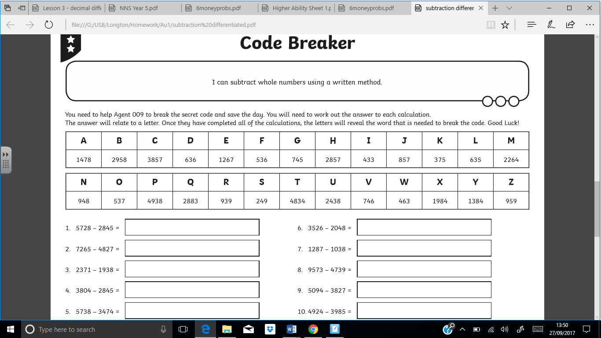

Word to crack the code:

Self-assess: Remember, if you fancy a challenge, there is a spicy sheet on the blog. 😊