Hi There.
We’d like to introduce ourselves as the newest members of your PTFA committee. We are available to hear your thoughts, bounce your ideas off and generally help provide you and your child’s time as Longton Primary school a memorable and fun time.

Why does the school have a PTA?
The main function of our PTA is to support the school by raising as much money as we can to enhance, enrich and improve learning experiences for the children. We also provide those 'little extras' that make school memorable, such as film nights, Easter bingo and Breakfast with Santa.
The PTA is run by a committee who are all volunteers this includes parents, family members, friends of the school as well as teachers. Each class has a parent representative who are on hand to answer any questions you may have about upcoming events and how you can help out in any way.
Our meetings are informal and are a great chance to join in and give any ideas you may have, feedback on past events or just sit and listen whilst enjoying a brew. We have members of the PTFA who are brand new this past year and those who have been within the group for a while. Everyone is welcome whether it is to just one meeting, them all or most importantly on hand to help out at school events for the children.

Recent events held and how much we raised
Christmas Winter Warmer | £ 2050
Christmas Shop | £ 483
Halloween Disco | £ 383.50
Valentine’s Disco | £ 349.83

What the PTFA funded with the money
What did we buy? | Who for? | What were the benefits?
Electronic White Boards | Teachers and all the children | Interactive current learning to benefit both children and teachers
Ball Cage | Children | A safe place to play outdoor ball games.
CCTV | The whole school | Ensure a secure safe place at all hours
Glockenspiels | Children and Teachers | Enables all children to be involved with the learning music activities at the same time.

How we keep you up-to-date with our activities?
Facebook group | Join our Facebook group  LONGTON PTFA  for up to date info on upcoming events - amounts raised - volunteers needed - equipment needed etc
Online Communication tool | The lovely Linda on reception is fab at sending out information needed on upcoming events on the calendar for the children and any donations needed to make these events great for them.

How can you get involved?
All parents are automatically members of the PTFA when their children start the school and we value each parent’s input and help for all PTFA events throughout the school. Feel free to come to any of the meetings and as we know all parents and families’ lives are busy if you can’t make the meetings but would like to help just give us a shout and we can point you in the right direction. The more people become involved, the more we can achieve and the easier it will be and bigger success in raising money for the children and school.

Contact details
We'd love to hear from you. Your committee board members are -

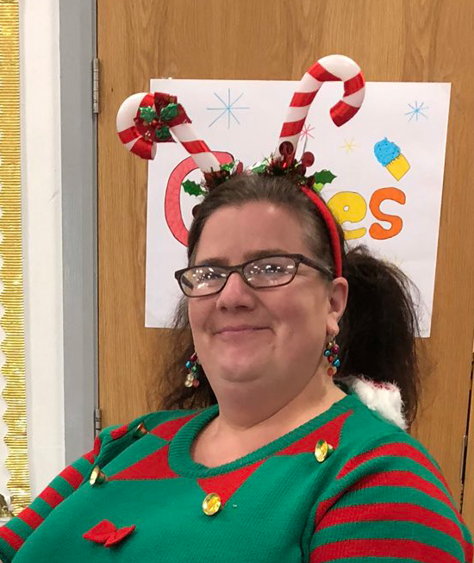
Kelly McDowell - Chair
Kelly runs the famous ‘Kelly’s club’ and the kids love her. She has been part of the school for 4 years and has experience of childcare for 14 years. Kelly is also a Beaver leader for 10 years and manages her son’s rugby team for the last 3 years.

Suz Dunbar - Vice Chair
Suz is mum to Frankie in Year 1 as well as Parker at home who is 2 and is new to the PTFA. A wedding photographer with husband Iain she enjoys all the creative and organising aspects of the PTFA and is keen to get stuck in.

Helen Dixon - Vice Chair
Helen has two boys now at the school with James in year 1 and Will in year 4. She has been a member of the PTFA for 5 years and has experience in working both within the school and with children.

Linda - Treasurer
Linda is amazing at helping keep a check on all the money, tickets and distribution of funds for the PTFA. She will always be on hand in school to receive donations or confirm any information about events coming up. She has worked with the school for a number of years and is a great asset to the PTFA

You can find us around school if you want a chat about ideas or information or jump on our Facebook page for any other info about upcoming events.

