An Investigation of how reading for pleasure can be delivered through a cultural education collaboration between schools, a library and cultural partner?

A SLiCE Research Project - Sandra Fletcher – Longton Primary School

Introduction

The question of how reading for pleasure can be delivered through a cultural education collaboration between schools, a library and a cultural partner? was given to the Specialist Leaders in Cultural Education ( SLiCE ) Fellows by Curious Minds and Lancashire County Council’s We Are Reading Initiative as the focus for action research in the academic year 2018 to 2019.

A relationship between myself as SLiCE, Dawn Worthington (Education Officer for the Harris Museum and Galleries) and Tom Brown (Library Officer, Longton Library) was facilitated by Curious Minds to establish a three-way cultural partnership for the programme. This research paper aims to answer the initial question and also questions that arose during the research into the ways in which museums, galleries, libraries and schools working collaboratively can develop reading for pleasure and ultimately impact on reading standards.

This research report has been compiled through reflective consideration of the process undertaken, outcomes observed and reading around the work of museums to develop curriculum links.

The 2014 Primary National Curriculum is very much geared towards teachers nurturing and developing a love of reading in pupils. One of the overarching aims of the curriculum is to develop the habit of reading widely and often, for both pleasure and information.
( Department for Education, 2014). The nature of statuatory assessments could be said to have taken its toll on reading, altering perceptions of it as a pleasurable activity to a chore, a tick list of skills to pass a test, which is reflected in the findings of The Beanstalk Charity (2017), 58% of children starting primary school are already behind in their reading and 34% of children leaving primary in England are unable to read to the required level.

The benefits of reading academically, socially and personally are widely documented. (OECD 2010 ) states that reading for pleasure is more important for children’s cognitive development than their parents’ level of education and is a more powerful factor in life achievement than socio-economic background.

It is therefore our duty as educators to ensure that children can decode proficiently alongside equpping them with a life long love of books using a range of strategies, good quality texts and to find and promote reading opportunities within our communities.

The question posed for the focus of this study by Curious Minds and Lancashire We Are Reading was well framed as to the line of enquiry to follow and thought provoking in nature. After a false start in the planning stage of the process and much soul searching, a moment of enlightenment and the recollection of the word legacy being used during the induction meeting changed the pathway this project and research would take. Just how could the wonders of a museum be used to foster the love of reading? What legacy could this project and research produce? Were teachers and schools fully aware of the local museum and confident enough to use it? What were children's thought on reading in musuems?

All of these questions became the focus of the study and will be adressed through the findings of this research paper.

Methodology

Following visits to The Harris Museum and discussions with the Museum Education Officer we decided to create a series of suggested reading lists linked to the Education sessions offered to schools. The SLiCE coordinated the research into texts of all types linked to each of the session, calling upon the epertise of the Library Officer at Longton Library. Other local schools were also invited to join in to create Legacy at this stage to add depth to the range of literature suggested.

To gather the opinion of children towards Museums and reading a small group of children from across Key stage 2 at the SLiCE school, with an interest in history and reading were asked to consider the question ‘Do you think museums can encourage children to read?’ The school is an average-sized primary school set in a large village on the outskirts of Preston. The proportion of disabled pupils and those with special educational needs at the school is below average and the proportion of disadvantaged pupils for whom the school receives pupil premium funding is well below average. The overwhelming majority of pupils are White British. They accomapnied the SLiCE for a morning to The Harris Museum.
In follow up discussions with the children key aspects of the research question from their perspective were gathered. Their thoughts are included in Appendix 1

Whilst visiting The Harris to discuss the first draft of the reading lists a discusssion began as to how schools could be encouraged to use the museum more widely and the question was posed do teachers feel confident enough to conducted self lead guided tours to enhance the work of the education department?

Following this the Headteachers from two local schools, along with the SLiCE school were offered a cultural opportunity for members of their staff to spend time at the museum. Time with the education officer, time to become familiar with the exhibits and galleries and time to look for reading opportunities.
Feedback was asked for and can be seen in Appendix 2.

Creating a Legacy for the Library was also taken into consideration and children from the SLiCE school met with the Library Officer to discuss how libraries work, the services libraries offer and how reading for pleasure can be promoted. From the information gathered the children are wotking to produce a guide to

The nature of the work undertaken during this project has meant that the collection of quantataive data has not been possible so far. The Harris have been provided with a review system which will allow them to measure the impact of the work over the coming years.

Research Findings

A large part of this research has involved extensive reading around the impact museums and galleries can have on learning and how these findings could be adapted to develop reading for pleasure .

Pupils are all unique individuals with different motivations and tastes. The reader should find the topic of the text interesting and there needs to be an array of books representing a variety of topics, levels of difficulty and genres of literature (Cole, 2002,) This premise fed directly into the thinking behind the project undertaken with The Harris. Care was taken to source a range of texts that took into account age, were not gender biased whilst taking into consideration the proven preferences of boys and girls.

Macdonald (1998) drew peoples attention to one of the most productive theoretical developments’ in cultural museum studies, ‘the analysis of museums as “texts” . Taking this statement at its most literal and asking children to think about museums as a place to encourage reading led to a group of children from the SLiCE school visiting The Harris Museum. The group consisted of children from Key Stage 2 ( Year 3 to Year 6 ) and were a mix of genders. Prior to the visit the children were asked do you think museums can encourage children to read ?

Child | Response
1 Year 3 | I think yes because there are interesting things so they might want to find books to find more things about it.
2 Year 5 | Yes, because it has loads of interesting things that we would want to know more about. Then people might want to try other types of books.
3 Year 6 | Yes, because you usually read information about artefacts which will encourage them to read more information books, maybe about dinosaurs, history or stuff like that.
4 Year 4 | Yes, but it depends on what the museum exhibits are. If it has books, yes. If it doesn’t have books no or maybe.

All of the children felt from their previous experiences of visiting museums that reading was encouraged. One child’s response “Yes, but it depends on what the museum exhibits are. If it has books, yes. If it doesn’t have books no or maybe.” a thought that was reflected on at a later stage.
As the children toured The Harris, they found books to read and the child who made the statement quoted began to realise that he was reading without picking up a book. Thus, cementing the idea of museums as “texts”

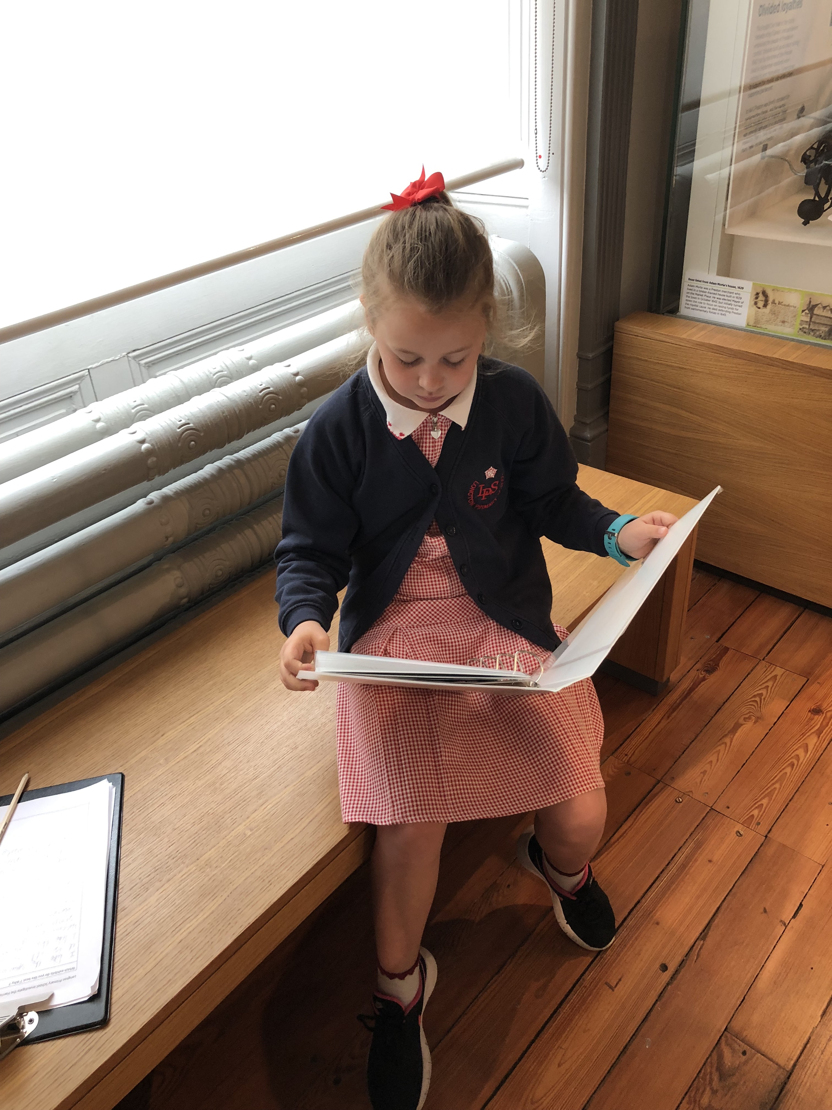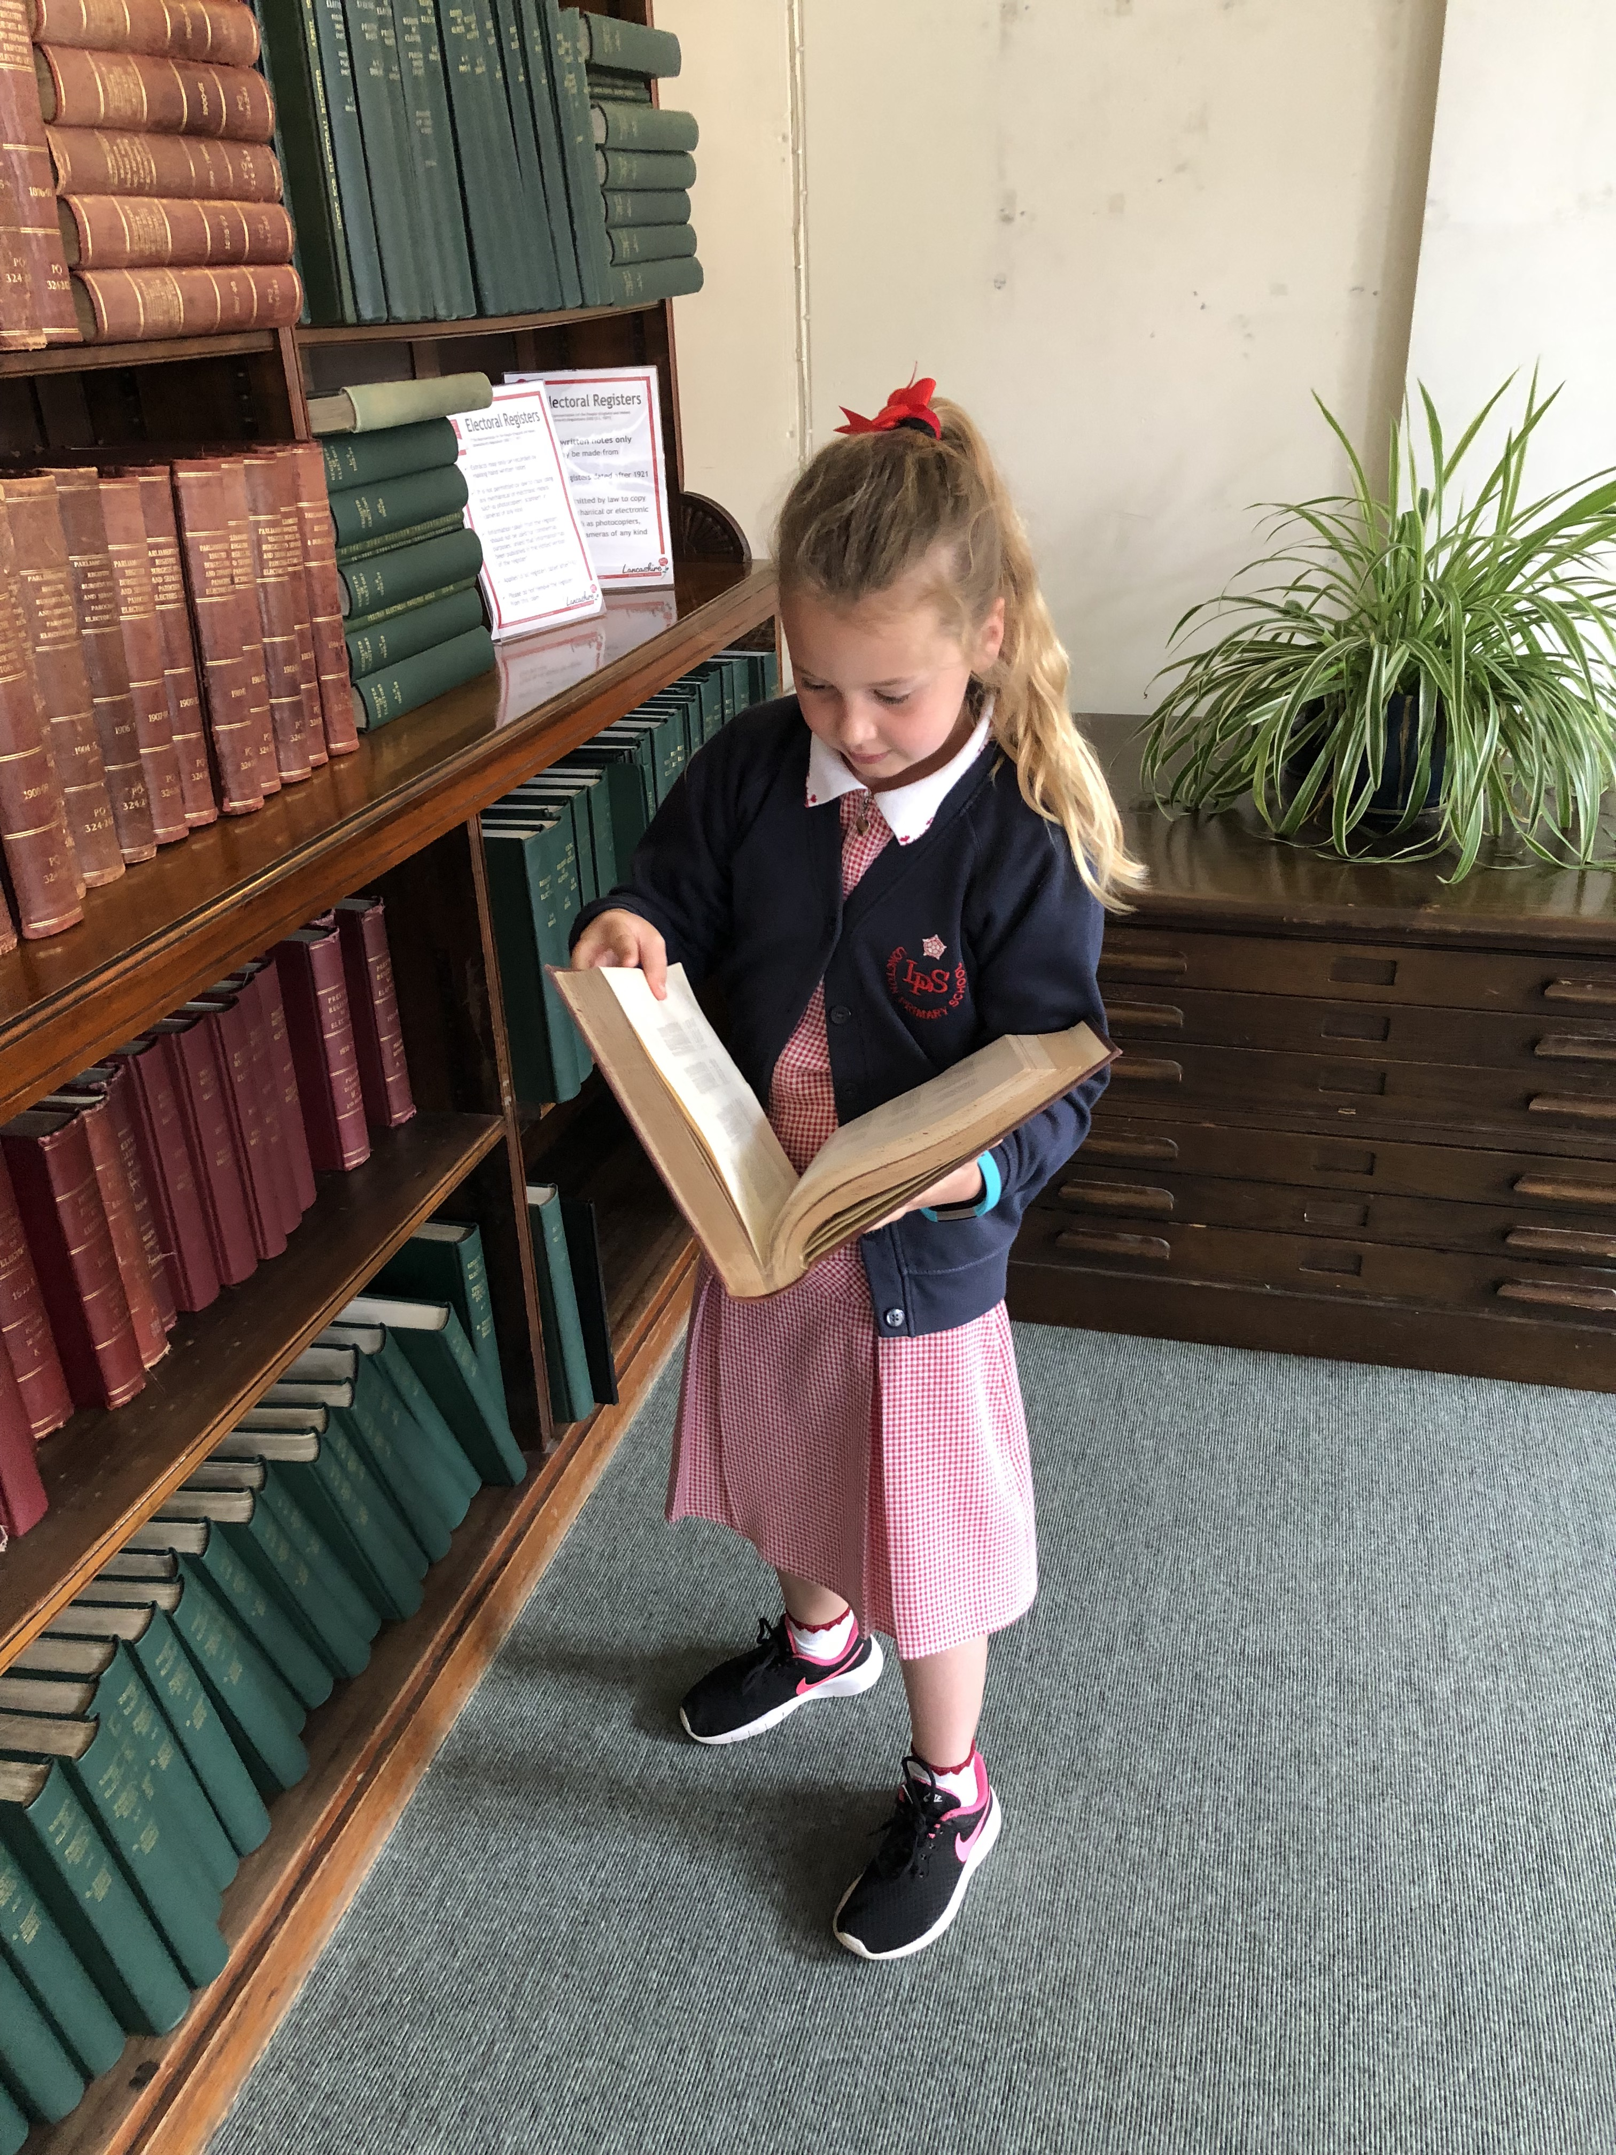

“Yes, but it depends on what the museum exhibits are. If it has books, yes. If it doesn’t have books no or maybe.”

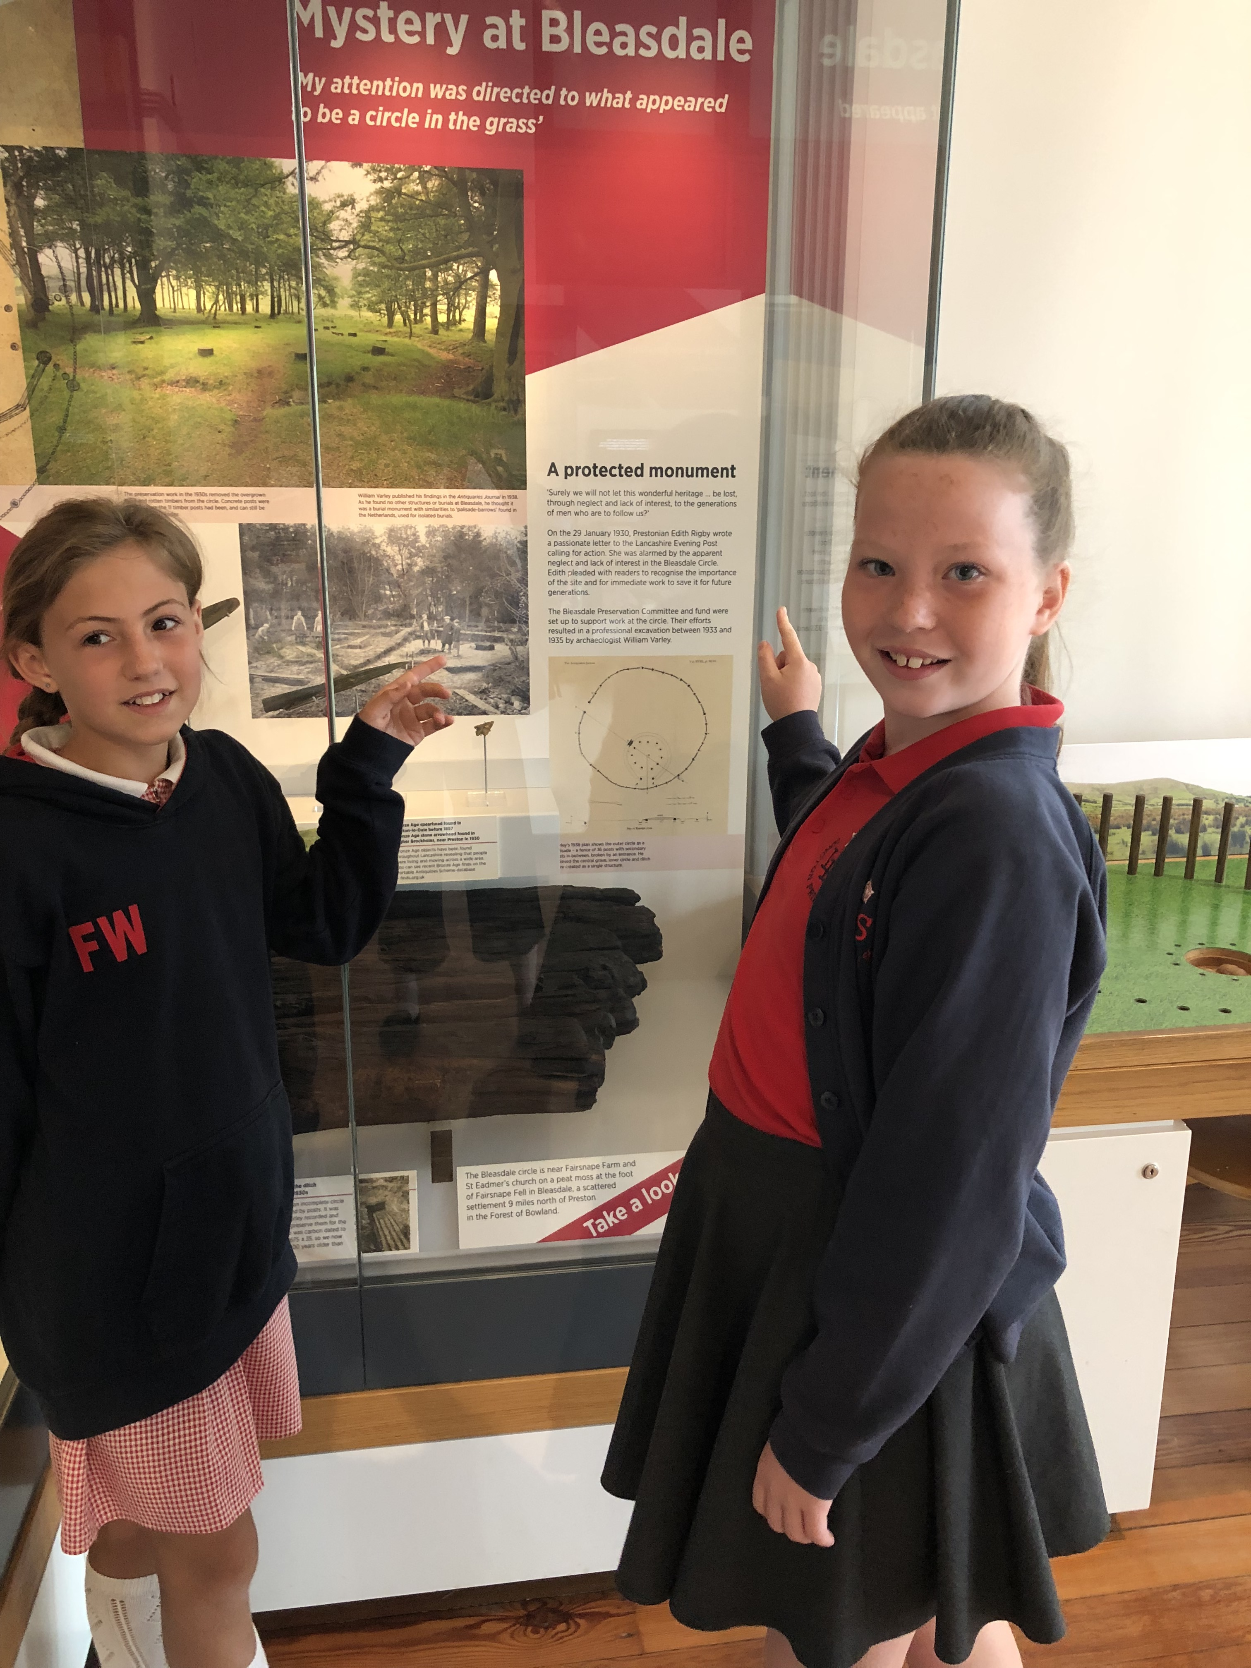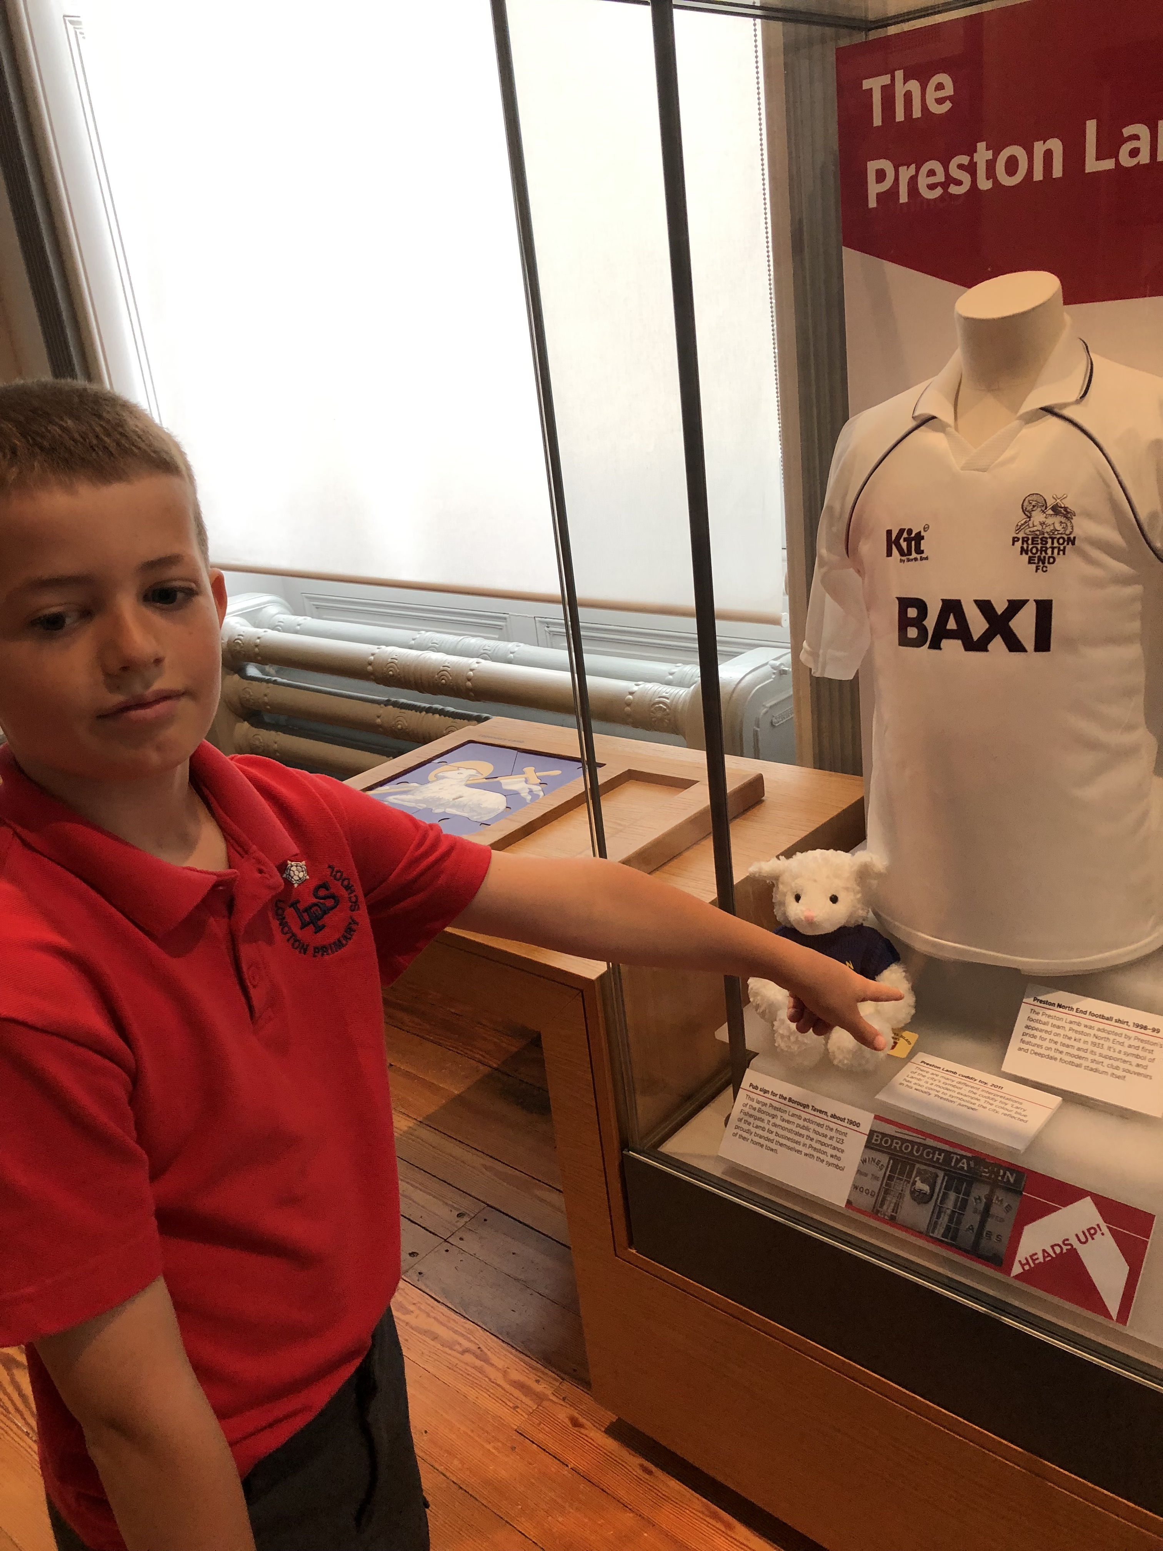

the analysis of museums as “texts” .

The very way in which collections are displayed in museums and galleries envelopes the visitor in text, texts that draw the eye and pique the interest.Texts that individuals choose to read or not to read depending on their level of interest in a particular topic.

At the end of the visit the children considered the question; From our visit today is there anything you would like to be able to read about? Each member of the group came up with an extensive list, once again consolidating the idea that museums can develop reading for pleasure. The lists can be viewed in Appendix1

Published research by people such as Dutro (2002) and Whilhem (2000) make reference to the difference in attitudes between the genders towards reading, what is perceived to be a “girl text “and the preference the majority of boys show towards texts that have a purpose. The group discussed this and noted that “the museum provided reading for purpose as the exhibits gave you information that you wanted to know.”

Before leaving The Harris, the children were again asked to consider the question do you think museums can encourage children to read ?

Child | Response
1 | Yes, because there are posters on the wall so people can read them
2 | Yes.  There are lots of things to read in museums. Children might want to read more when they get home so they might go to the library or the bookshop.
3 | Yes, because if they find something, they like they might read more or find something to do with it and keep reading.
4 | Yes, all museums. Even the ones without books.

The reading undertaken and the discussions with the children were important factors that underpinned the selection of texts used to compile the materials that were produced to offer reading opprtunities following participation in the educational sessions offered at The Harris Museum.

During discussions between the SLiCE and the Education Officer at the Harris the question of how confident teachers feel about visiting musums and in particular conducting self – guided tours to enhance learning across the curriculum including reading arose.
DCMS/DfES (2003- 2004) found that amongst the teachers they were working with during the project 66% were using the museum for the first time , 94% of the teachers said that museums were important for their teaching and at the end 90% felt their visit had increased their confidence to use museums. The Harris felt that teachers were quite happy to visit for guided sessions but not confident when it was suggested they conduct a self guided tour.
This lack of confidence undermines the impact museums anywhere in the country, indeed the world can have on learning. Museums provide opportunities to make learning fun, they overcome barriers, offer new experiences, give children a real purpose and context to write and provide a measurable improvement in literacy levels and standards of work . (Renaissance Northwest, 2008). This can equally be applied to reading. Through this lack of confidence teachers must ask themselves if they are denying children a whole host of opportunities to learn and to read in an environment that by its very nature is full of quality texts?
As a result of this discussion and reading research papers around this point staff from local schools met with the Harris Museum Education Officer . The staff involved found this opportunity beneficial and their feedback to both the Education Officer and the SLiCE has given both parties ideas to develop in terms of provision and continous professional development for teachers.

Research reports a link between library use and reading for pleasure; young people that use their public library are nearly twice as likey to be reading outside of class every day (Clark and Hawkins, 2010). Historically the relationship between the SLiCE school and Longton Library has been strong, and the work undertaken in this project has served to strengthen the link. When the project changed in nature the link between the three parties became looser. In light of the importance libraries have in promoting reading for pleasure other ways were found to develop a legacy linked to proven research. Clark and Hawkins (2011) conducted online research with 17,089 children aged between 8 and 16 from 112 schools to explore library use. The findings of the survey found that the majority of children said reading was important to succeed in life. Other key findings show:

- 48% of children said that they do not use public libraries at all;
- Children from white backgrounds use public libraries least (48%);
- Public library use declines significantly with age, with 63% of Key Stage 2;
- Public libraries do not disproportionately attract chidren from more or less affluent backgrounds;
- Of the 44% of children who do use the library, the most common reason cited by over half of all children was that the library had interesting reading materials.

This data shows that it is imperative to promote the use of libraries in communities that still have such services. Moran (2011) states that a library in the middle of a community is a cross between an emergency exit, a life raft and a festival. They are cathedrals of the mind, hospitals of the soul, theme parks of the imagination.

Information collected through children interviewing the Library Officer supports all of Moran’s statements (appendix 3 ).It is imperative that these qualities are publicised. Social media has proven to be a key way to promote the work of the library ( and the museum) to the school community and evidence in children's holiday journals shows more visits being made to both establishmentsduring the academic year 2018 to 2019. In order to promote the library staff have collaborated to support each others initiatives. A reward system started within the school setting to promote reading for pleasure has been linked to the Lancashire Reading Trail allowing both reading challenges to compliment each other. Rewarding reading has over time split thinking, with some such as Edmunds and Tancock (2003) finding no significant differencs and Clark and Rumbold (2006) concluding that literacy- targeted rewards,are more effective in developing reading motivation than rewards that are unrelated to the activity. The impact of this collaboration will be measured throughout the academic year 2019 to 2020.

Conclusion

To conclude from the findings above and in answer to the original question posed, it has been discussed and shown that reading for pleasure can be delivered through a cultural education collaboration between schools, a library and cultural partner or a configuration of these collaborations. The findings of this research show that Schools have a duty to ensure that children develop a love of reading. It also highlights the need for cultural organisations to work together to enhance reading . The skills and knowledge of staff within schools, museums and libraries can compliment each other, allowing adults to widen their knowledge base and support each other to deliver unique , bespoke opportunities to engage children in reading. The Legacy created for The Harris and Longton Library will inform children throughout Preston and beyond and allow them to lose themselves in a world of books for many years to come.

Next Steps

- Continuous Professional Development opportunities for school staff to visit Museums and libraries to meet with staff and see the opportunities for collaboration.
- Investigate how Museums can promote themselves to local schools .
- Publicise the reading lists available at the Harris Museum.
- Further deepen links with the library service to promote the work they do and the services they offer.

Continue to work together to establish “an appreciation and love of reading which feeds pupils’ imaginations and opens up a treasure house of wonder and joy for curious young minds” (Department for Education , 2014)

Acknowledgements

With special thanks to the following for their support, contribution and participation in the project and towards the resulting report:

Jude Bird at Curious Minds
Paul Duckworth – Lancashire County Council, We Are Reading
Dr. Sandra Hiett , Liverpool Hope University
Dawn Worthington, Education Officer, The Harris Museum, Gallery and Library Preston
Tom Brown, Library Officer Longton Library
Julie Brown, Headteacher, Longton Primary School
Staff, Governors and children at Longton Primary School
The parents at Longton Primary School
Staff at Little Hoole Primary School
Staff at Hoole St Michaels C of E School

References

Beanstalk Charity (2017) Stories, songs and art to develop language and literacy skills p.1

Clark, C and Hawkins, L (2011) Public Libraries and Literacy: Young people’s reading habits and attitudes to public libraries, and an exploration of the relationship between public library use and school attainment.

Clark, C and Rumbold K (2006) Reading for Pleasure a research overview The National Literacy Trust

Cole, J.E (2002) What motivates students to read: Four literacy personalities. The Reading Teacher p.326-336

Department of Education English programmes of study: key stages 1 and 2 National Curriculum in England (2014) p.3

Department for Education and Skills (2003-2004) Inspiration, Identity, Learning: The Value of Museums p.4

Dutro, E (2002) But that’s a girls’ book! Exploring gender boundaries in children’s reading practices. The Reading Teacher p 376-384

Edmunds, K.M and Tancock, S.M (2003) Incentives: The effects on the reading motivation of fourth -grade students p .17-37

Macdonald, S (1998) The Politics of Display: Museums, Science, Culture

Moran, C (2011) The Times Magazine

OECD (2010) Pisa 2009 results; Learning to Learn Considine, J (2017) Hooked on Books Transforming the Teaching of Reading p.9

Renaissance North West Museums for changing lives (2008) Write on How to use museums and galleries to improve pupils’ literacy

Wilhem , J.D (2000) When reading is stupid: The why, how and what to do about it. In E. Close and K.D Ramsey A middle mosaic: A celebration of reading, writing and reflective practice at middle level p3-10)

Bibliography

Atkinson, P (2019) UKLA Promoting Reading for Pleasure

Cosidine , J (2017) Hooked on Books Transforming the Teaching of Reading

Department for Education (2012) Research evidence on reading for pleasure

Digital Education Resource Archive (2015) The Learning Power of Museums

Gabriel, R and Gabriel, M (2010) Power in Pictures: How a Schoolwide Photo Library Can Build a Community of Readers and Writers

Hope, A (2018) Young Children as Curators

Izon,S (2019) Research- based training-translating evidence into practice one bite at a time

LaBrocca, R and Mandel Morrow, L (2016) Embedding Vocabulary Instruction into The Art Experience

Merisuo-Storm, T (2006) Girls and Boys Like to Read and Write Different Texts

O’Keeffe, H, Grimshaw, N and Talbot-Landers C (2019) What are you doing? Oh, I’m just looking at the art! Children in residence at Tate Liverpool

Settle, K (2016) Increased reading and Literacy: how libraries deliver

Appendix 1

Visit to The Harris Museum 5th July 2019

Q2 Which exhibits do you like best? Why?

Child | Response
1 | I like the spun glass ship because it is all colourful and pretty. I like the coloured glass because they are all different shapes and are very colourful to look at. I like the teapot and the pair of candlesticks because they have lovely patterns on them.  I like the art glass bottles because they have different types of patterns. I like the tunnels because there is a mole and worm. I like the Manchester Riots because they look like water splash up in the sky  I liked the guild chair because it was very old and large, I liked the chess set in the art gallery. I liked the Viking trade exhibit
2 | An introduction to glass because it has really nice art and glass. It has something that looks like a jumbo unicorn horn. It has amazing designs and colour work. I also love the colours of the glass because of it’s amazing colours and shades and it has amazing detail
3 | The glass exhibit, it’s interesting because of the design and the colours they used.
4 | Staffordshire figures, mugs, vase, Wedgewood, cut glass bottles. Oldest scent bottle made in 1685. Liked the shapes and colours (added verbally)  The Elk, display on the docks – exciting  The room with the old books- the smell  Looking at the art- reading the pictures- the meteorite, the big head.  The Fashion by the UCLAN student who came from China  The Viking exhibition- fun and interesting  Writing my name in Runes  Makes me want to write a comic about a Viking Blacksmith and /or ancient clothing

Q3 From our visit today is there anything you would like to be able to read about?

Child | Response
1 | - Preston docks  - Made for a king  - The guild chairs  - The street style exhibits
2 | - The carnivals  - Fashion  - William Roberts  - The Common Market Painting  - The meteorite lands in Epping Forest painting  - The Bug style dress in Preston Street Art
3 | - The cockle pot, it’s really old but looks really modern  - Blue whit pottery, the prints on them, where do they come from? why did they choose it?  - How did they get the colours?  - Being shot in the foot was that the reason the elk died?  - More about Peddern dolls house  - The Common Market painting why did the artist use a lot of straight lines?
4 | - The mystery of Bleasdale  - Ancient Preston docks  - PNE, days on top  - George Chambers  - Bing Hong  - Viking trade  - More about famous paintings

Q4 Would you prefer fiction, non-fiction or both?

Child | Response
1 | Both
2 | Both.
3 | Both.
4 | Non-fiction.

Appendix 2

Teacher Feedback

1
I had a great day and my mind is genuinely full off ideas. Talking with Dawn it was clear to see her enthusiasm for the Museum. I shared with her our current topics and she gave me the outline of the workshops they have. I didn't realise they had so much Ancient Greek materials.
Going around the galleries it was also interesting to see what other links we could use. for example - looking at Greek democracy and following that through to Preston's Lune St. protests following on from Peterloo in Manchester and then onto Suffragettes and Edith Rigby. All of which is in on the first floor. Talking with the DH from the school Becky's a governor we talked about creating a new topic. "Nothing exciting ever happens here" what a good way to look at your local history- this could link into Preston north end and the creation of the football league, the bus station and the creation of the buffet which was so well received in WW1 that it was continued in WW2. we would also look at the Preston guild itself.

Up on the Gallery: we looked at the artwork. Talking with Dawn, we made links between the Docks, and artwork dotted around the gallery as well as literacy writing sessions based on objects around the museum.

I’m currently torn between going for a session on ancient Greece where the sculptures and artwork is used to create their own best and myth or looking at the idea of nothing exciting happens here. ...I did debate if this would be something another class would like to join us with.

2
Harris Library Visit – 13/9/19
As part of SLICE which Sandra Fletcher has been key coordinator, I was invited to go to the Harris Museum in Preston to find out what they could offer school.
Dawn was very informative and answered any of our questions with confidence and detail.
Our tour started in the Library – I took lots of photos and have already added simple quotes about reading into my class reading area.
I looked at the different ideas/games that they had out and Dawn informed me that if I chose to do one of the visits, she could ensure that we had a ‘time’ in the library added on.
We then visited the first two floors and Dawn informed us about different artefacts:
- Perfume bottles
- Tea pots and pottery
- Greek representations around the Harris and how that had come to be
- We then went to find out about the ‘Elk’ that had been discovered in Poulton
- The Docks memorabilia
- The cotton mill artefacts
- Edith Rigby - suffragettes
- Old Toys – which I am hoping to use for a class trip
- Artwork – and the links that we could make through school e.g. fruit market/Handas Surprise/Bananas that came to Preston
- Clothes from the past to present
- Art Gallery and the spaces how they are used e.g. yoga mats in front of pictures.

3
I really enjoyed my visit last week and it was very clear that Dawn knew the exhibits inside out and shared her breadth of knowledge with us. It was great to have a booklet about what is going on in the museum in terms of educational sessions that they offer, and I have shared this with staff at our staff meeting.
In terms of the exhibits, I loved the Preston one and came up with a topic of 'Nothing Much Ever Happens Here.' We can then build our unit of work around that for Year 5 and 6. This would replace nicely the Blackpool unit from Lancashire. It would allow the children to build a real historical sense of where they belong.
I loved the Greek exhibits too - this is a great topic for UKS2, and I will definitely dip into these resources.
The artwork around the museum linked beautifully to these topics too - the new quiet spaces would provide a great reflective time for any class visiting. The Stone Age resources are brilliant for Year 3 and 4 - we would have to be careful that there is enough for them without overlapping to Preston.

I do feel more confident to lead a self - guided tour without a doubt. I think the children would be inspired by the links especially to Greece and Preston.
I feel that lower year groups might struggle to justify the cost of a coach there, as the other exhibitions are quiet limiting. The teacher taking them would have to plan carefully and this involves looking at the curriculum across the school - which we are currently doing.
I loved the experience.

Appendix 3

4th July 2019 Library Visit

Children asked Tom

- What is your favourite thing about the library?
- Potential for so many different things in the library, books, computers. It is a place for the community to do things- hobbies, classes, activities
- Activities for children in the holidays. If you work in the library, you can bring your idea and interests e.g. I want art classes in my library, I want to teach art

Tom asked the children
What do you think libraries are?

Y5 – where you can read loads of books, borrow books, borrow CD’s
Y4- a place to come and relax, be chilled out from the rest of the world
Tom – people come here to study because we have tables and chairs and can use own laptop or the library PS’s
Y4 – a place to escape into your own world and thoughts.

Tom – the computers have internet access for those who don’t have it at home or who have limited access. Connects people to the world, social media, websites for info and news, events, shopping. Access is free. Library also has public WIFI

Tom – there are approximately 50 to 70 libraries in Lancashire. All the books are Lancs library books. Books are changed and borrowed between libraries e.g. a library in Burnley wants a book from Longton
If there is a book you want to read, you can reserve a copy.

The books in the library change- there are between 10 and 20, 000 books on the shelves.
Lancashire libraries are in a partnership with libraries from around the country so can request books from elsewhere e.g. London, Edinburgh. It is a huge network.

It is free for children to request books, adults 75p – can take time for book requested to arrive in Longton. On average it takes 7 to 10 days to meet a request.

People who use the library
Older people
Adults of all ages – mums, dads, grandparents
Children use the library for activities, borrow books, DVD’s, use the computer, visit with school.

Teenagers / young adults – a place to study/work/revise, borrow books to help with studies, use the internet
THE LIBRARY IS A SAFE PLACE WITH FACILITIES

Toddlers- share and borrow books with parents, toddler activities – baby bounce and rhyme Friday 10.30 – nursery rhymes and action songs such as Old MacDonald and the Wheels on the bus.
Hold sessions for toddlers and babies to encourage them to come into the library when they are older.
They come and have fun plus nursery rhymes and songs are really good for helping children who are learning to read/speak- they are the first steps to literacy.

Libraries have something for everyone
Different things for different people, different communities, different ages

A library card is needed to borrow things but not to use the facilities or for the activities.

Library card – takes a few minutes to fill in – name, date of birth address. Can do it in the library or can join online on library website

Opening hours
Monday 9 to 5
Tuesday 9 to 5
Wednesday 9 to 1 (half day)
Thursday 9 to 7 (late opening)
Friday 9 to 5
Saturday 9 to 1

How many books can you borrow?
Up to 20 at a time.
20 items – CD’s, DVD’s, books, talking/audio books, books
Can borrow books for 3 weeks, music CDs and DVDs for 1 week
Books are free to borrow, CDS 50p DVDs £1 or 50p depending on rating U= 50p e.g. Disney films
PG, 12 etc. =£1

ON GUIDE MIGHT BE AN IDEA TO INCLUDE DIRECTIONS TO LIBRARY AND TRANSPORT LINKS
Include an online map on web page

People get to the library by walking, car- there is parking in front of the library
By bike
Bus links - bus 2, 2A or 12
The target area of the library is Longton, but people come from
Penwortham, Hutton, Walmer bridge, New Longton, Preston
People come from all over the county, have even had visitors from around the world e.g. from America to see where family was from.
War memorial – people come to find out about family history and their ancestors.

If making an internet-based guide
Have a website link
Social media Facebook
Twitter
Maybe Instagram
For lancs library service
Page on our school website
@lancspubliclib = Twitter
Include a book review

Activities in the library include

- Reading challenges – summer holiday challenges,
- Lancashire Reading Challenge 4 to 11 (Primary School – Lancashire Reading Trail – get map, charts progress, bookmarks, character cards
There are reading schemes all year round similar to the one we have in school. Library one goes to 50 books not 25 Read a book, write a short review or tell a librarian about the book

10 books – bronze, 30= silver, 50= gold – certificate
When reach gold you also get a book signed by an author
All the books read at Longton as part of our challenge can be included in library challenge a special deal for our school only

Activities for adults
Regular
Computing
Craft and chat – bring a crat activity along and sit around table and chat
Family History – help with finding out about ancestry and your past
Games afternoon- friendship whilst playing games such as card games canasta, board games
Wednesday morning – singing for well-being – gives a sense of well-being and happiness
Reading groups- discuss books read
Table top games evenings

Library also asks people what they would like to see going on in the library.

Longton live venue on Friday evening, 4 different performers
Singers. Musicians, poets, short plays, dance

Seasonal - children’s activities at Christmas and Easter
Last Christmas was taste of Germany – German food tasting

Teenagers
12 to 15 meets every Thursday afternoon – group called Great Minds
Have own logo
They organise and plan different activities they want such as Sensefest, open mic night
Next event – short films which they will make films plan to premier in October

Types of books
Borrow box – link – see green card is an app on phone or tablet to borrow e books/ audio books free borrow for 2 weeks but can renew for further 2 weeks
E book catalogue on website
Can have 6 downloads at one time which is not part of the 20 items
lancashire.gov.uk/libraries

pets in library – assistance dogs allowed
some special events – read to a dog – Bella

careers in libraries
find vacancies on lancs county council site
first work as a library assistant which is the job of most people in library – serve, help find books sort events

can be a library officer like Tom – manage library and staff link with schools do assemblies
can do a librarian degree at university
NVQ in customer service
library assistant – no qualifications desirable to have 3 GCSE especially English
need enthusiasm for books and reading, knowledge of computers and digital technology, friendly lively person, communicate well, talk to people, phone, email
can apply when leave school
can get work experience in library – build up experience and learn job to help application and interview

Sections of the library
Children's area – large= junior library
Computers
Books are in alphabetical order for fiction
Dewey system for non-fiction
Can rent room for meetings – PACT PARISH COUNCIL
Toilets, disabled toilet, baby changing facilities
Access for all

Website – page on school site
Posters, leaflet
Magazine format of half termly book reviews

