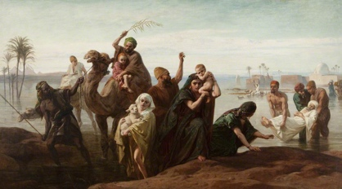
SUDDEN RISING OF THE NILE

Has today’s visit to the Harris Museum and Art Gallery inspired you to want to find out more about the River Nile or floods ?

Here are some fiction and non- fiction books that you might like to read. You may be able to borrow them from your local Library. Visit https://www.lancashire.gov.uk/libraries-and-archives/libraries/ for more information about your local library services.
Freddy The Fogcaster and the Flash Flood by Janice Dean

Freddy the Frogcaster and his friends are hoping for rain. Their town of Lilypad is dry, and plants and trees are brown because of a terrible drought. Freddy gets excited as he sees a storm coming that could bring water to thirsty trees and grass. He leaps into action to warn everyone to "be prepared!" Suddenly there’s a change in the forecast that could affect everyone’s plans―and make Freddy wonder if he’s meant to be a frogcaster.

Reading Age 4 to 8

Reading Age 5+

Flood – F. Villa Alvara

This beautiful picture book depicts the effects of a devastating flood on a family and their home.

Reading Age 6+

We’re Sailing Down The Nile – Laurie Krebs

Set sail along the mighty Nile River to experience the wonders of Egypt. The lilting, rhyming story text is followed by eleven pages full of educational information about ancient Egypt, gods and goddesses, a helpful map, and much more.

Reading Age 4 to 8

Journey Along The Nile - Sonya Newland

Travelling Wild: Journey Along the Nile follows a traveller on a fictitious journey by boat up the world's longest river. It uses the information you would consider when planning a trip, such as the weather, climate, dangers and key sights, to present geographical information in a highly enjoyable way.

Reading Age 9 to 12

Rising Waters A Book About Floods (Amazing Science Weather) – Rick Thomas

The science of floods explained for young children

Reading Age 4 to 8
Nile River (River Adventurer) – Paul Manning

Travel from Lake Victoria in Burundi, to Cairo, Egypt to explore the world's longest river as you learn about the landscape, ancient civilizations, and historic landmarks on the Nile. You will also learn about the people as well as the people who currently rely on river.

Reading Age 9 to 12

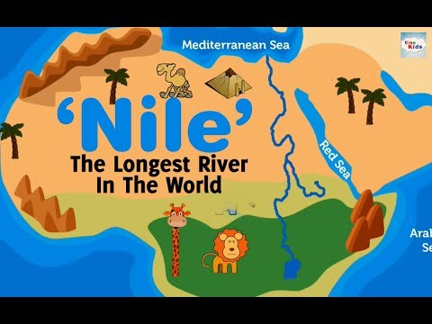
Matthew and The Midnight Flood- Allen Morgan

Matthew is on a mission to save the entire city from flooding. It's all up to him and the midnight plumber and they'll need every bit of their super- powers to pull it off.

Reading Age 7 to 8

More great books that you may want to try include:

- Wild Weather Floods by Lorraine Jean Hopping (Reading Age 4 to 8)
- Mom the School Flooded by David McKee (Reading Age 4 to 5)
- Elmer and the Flood (Reading Age 5 to 6)
- Mrs Noah’s Pockets by Jackie Morris and James Mayhew (Reading Age 5 to 6)
- The Nile (A River Journey) by Rob Bowden (Reading Age 9 to 12)
- Time Meddlers on the Nile Volume 3 by Deborah Jackson (Reading Age 9 to 14)
- Matthew and the Midnight Flood by Allen Morgan ( Reading Age 9 to 12)
- Flood Child by Emily Diamand (Reading Age 9 to 12)
- The Scarab’s Secret by Nick Would ( Reading Age 9 to 12)
- Settlements of The Nile by Rob Bowden (Reading Age 9 to 12)
- Unfolding Journeys – Secrets of The Nile by Lonely Planets, Stewart Ross ( Reading Age 9 to 12)

