1.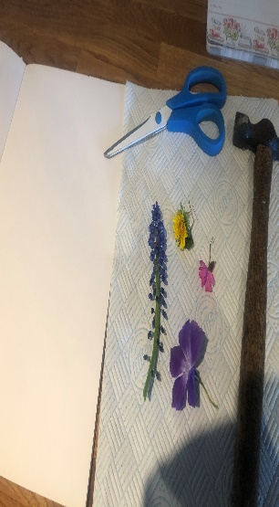 | 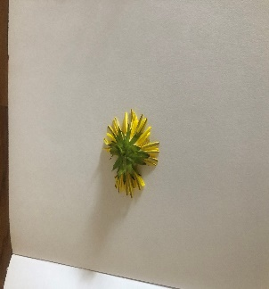  2. | 3.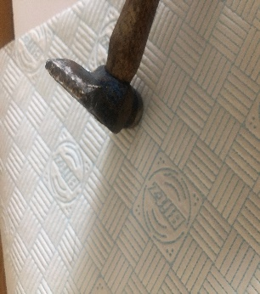 | 4.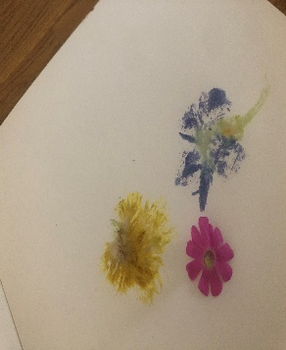
Tools that you need:  - selection of flowers  - scissors  - small hammer/tapper  - paper  - kitchen roll | Place the flower face done on the paper | Place the kitchen roll over the top and tap gently. | Do the same procedure with different flower heads. Each time you lift the kitchen paper carefully scrape off the flower that you have tapped!
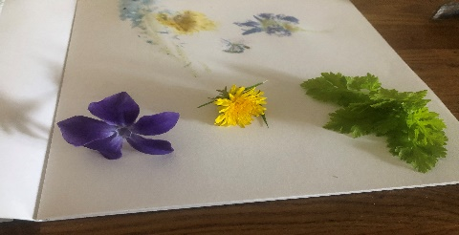  5. | 6.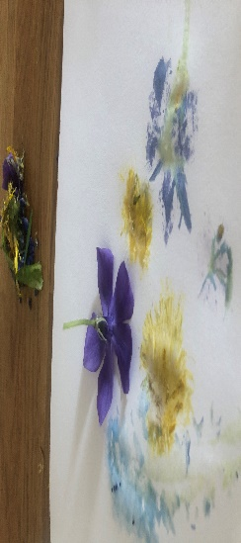 | 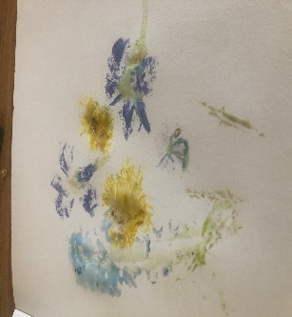  7. | 8.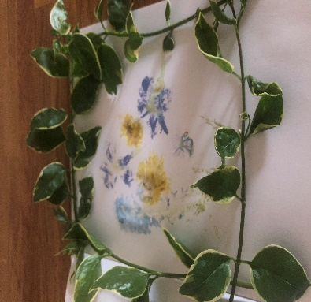
Try different flowers and leaves to see what pigments come out. | Arrange the flowers carefully to make your picture. | Finished tapping, I then collected some leaf branches. | I framed my picture with the leaf branches.

