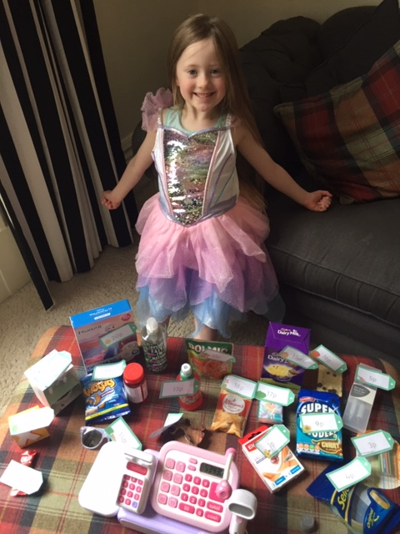

I would love to shop at Petra ‘s shop. I wonder what it would cost if I bought an Easter egg and some noodles?!