VE DAY
This week I thought it would be a great opportunity to learn more about WW2 and VE Day.
Choose one or more activity a day to explore. Be creative about how you present your work. Send any photos etc to your class e-mail address and we can post them in the blog.
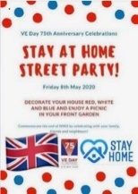  ‘Stay At Home’ Street Party  Read this article on Newsround and look closely at the photographs. How did people celebrate in 1945? Plan your own ‘stay at home’ street party.  What games could be played? What decorations would be put up? What food would be eaten? Who would be there? Is there anyone in your family who went to a VE Day party you could speak to?  For something more simple, you could design your own VE Day party invitation or create your own Union Jack flag bunting or make a Union Jack flag out of Lego! | Understanding World War Two/VE Day  On 8th May 1945, Britain celebrated the end of World War Two. To understand why VE Day was so important, you need to understand WW2. Visit these sites to help in your research:  Primary Homework Help - WW2  A Brief Overview of World War II – Video  BBC Teach - VE Day  What Is VE Day?  Can you create a simple timeline of important events leading up to  VE Day? | Wartime Recipes  With one rationed egg and a packet of powdered milk in the larder, World War II’s home cooks had to be creative. Find out what families were eating over 75 years ago.  Create some delicious meals using the recipe booklets below. You could serve them at your ‘Stay at Home Street Party!’  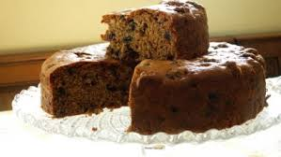  Wartime Recipe Booklet  Wartime Ration Recipes  WW2 Cake  Wartime Scones  Jam Tarts
VE Day Songs  Try and learn the Horrible Histories VE Day song and perform it to your family.  Create your own motivational song. Listen to some of the following clips for inspiration. Click here to listen to some more traditional war time songs as well as the links below.  Wartime song lyrics  Run, rabbit, run!  Long way to Tipperary/ Pack up your troubles  We’ll meet again  The White Cliffs of Dover  Learn step-by-step how to Swing dance (The Lindy Hop) which originated in the late 1920s and early 1930s in Harlem, New York City. |  | 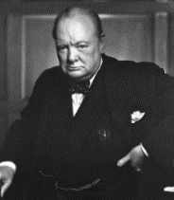  Winston Churchill  Who was Winston Churchill? Why do we remember him today? Produce a fact file/ poster displaying your information.  .  What was his job?  Why was he so important during WW2?  What was one of his famous phrases?  Can you describe his characteristics?  Why he was important?  You can read more about Churchill using these links from Twinkl and Ducksters. You may present this information in any way you choose or use this template.
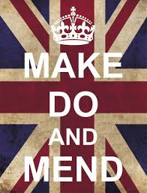  Make, Do and Mend  During WW2, there was a shortage of materials to make clothes. People were urged to "Make, do and mend".  Do you have any clothes or accessories that you could ‘upcycle’ into new clothing or something completely different to give it another purpose and a new lease of life? | 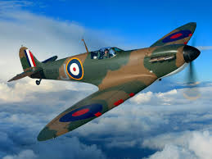  Spitfire Science  Design and make your own Spitfire. You could make it out of paper, wood, recycled materials, etc. Test out your design. How far does it glide?  Does the material used for a paper plane affect the distance it travels? Try using newspaper, card, tinfoil, etc and carry out a test..

