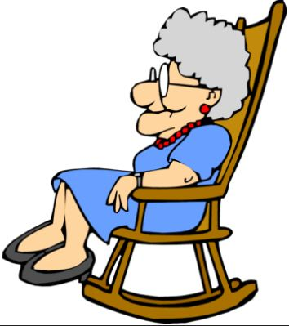
Gran Can You Rap?
Gran was in her chair she was taking a nap
When I tapped her on the shoulder to see if she could rap.
Gran can you rap? Can you rap? Can you Gran?
And she opened one eye and she said to me, man,
I’m the best rapping Gran this world’s ever seen
I’m a tip-top, slip-slap, rap-rap queen.
And she rose from the chair in the corner of the room
And she started to rap with a bim-bam-boom,
And she rolled up her eyes and she rolled round her head
And as she rolled by, this is what she said,
I’m the best rapping Gran this world’s ever seen
I’m a nip-nap, yip-yap, rap-rap queen.
Then she rapped past my Dad and she rapped past my mother,
She rapped past me and my little baby brother.
She rapped her arms narrow and she rapped her arms wide.
She rapped through the door and she rapped outside.
She’s the best rapping Gran this world’s ever seen
She’s a drip-drop, trip-trap, rap-rap queen
She rapped down the garden, she rapped down the street,
The neighbours all cheered and they tapped their feet,
She rapped through the traffic lights as they turned red
As she rapped round the corner this is what she said,
I’m the best rapping Gran this world’s ever seen
I’m a flip-flop, hip-hop, rap-rap queen.
She rapped down the lane and she rapped up the hill,
And as she disappeared, she was rapping still.
I could hear Gran’s voice saying, Listen Man,
Listen to the rapping of the rap-rap Gran.
I’m the best rapping Gran this world’s ever seen
I’m a –
tip-top, slip-slap, nip-nap, yip-yap, hip-hop, trip-trap,
touch yer cap,take a nap
happy, happy, happy, happy
rap-rap queen.
By Jack Ousby.

