Multiplication
For maths this week I would like you to focus on Multiplication.
You should be getting on great with your times tables knowledge now.
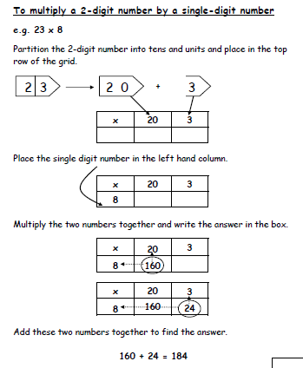
Before we finished we started to learn about the grid method for multiplying larger numbers.

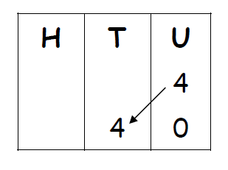
Remind yourself of how to multiply by 10 and multiply by 100.

so 34 x 5
x | 30 | 4
5 | 30 x 5 to work this out use what you know.  3 x 5 = 15  30 x 5 is 10x bigger so I need to make my answer 10x bigger.  15 x 10 = 150 | 4 x 5=  20

34 x 5 = 150 + 20 = 170

