Smash and grab.

- To get started gather a bat and all of the ball’s you can find and a bucket

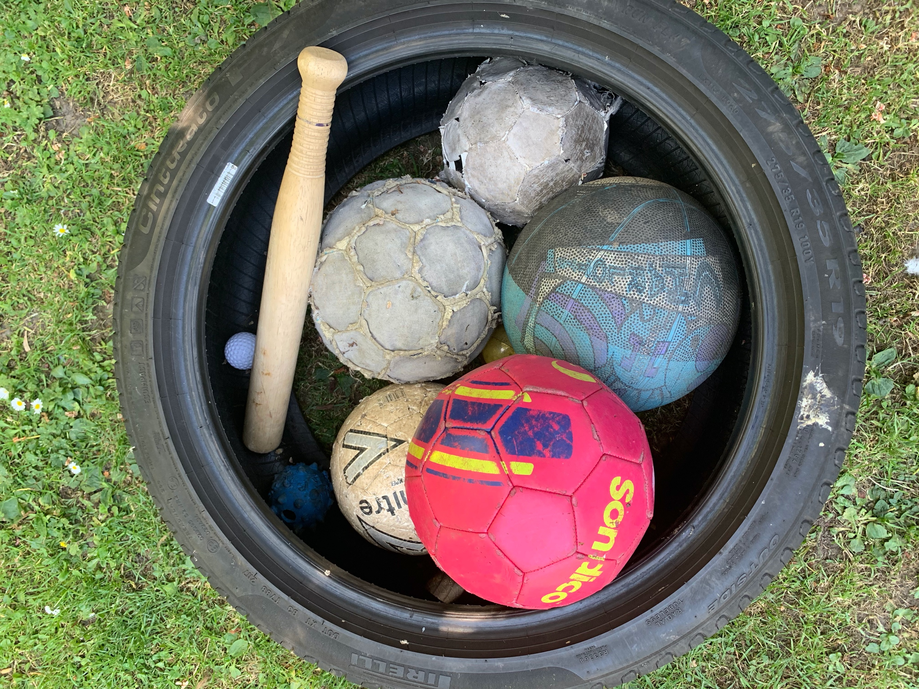

- Standing 5 meters apart one person named the bowler throws the balls the other person the batter attempts to hit it back to the other person who attempts to catch it

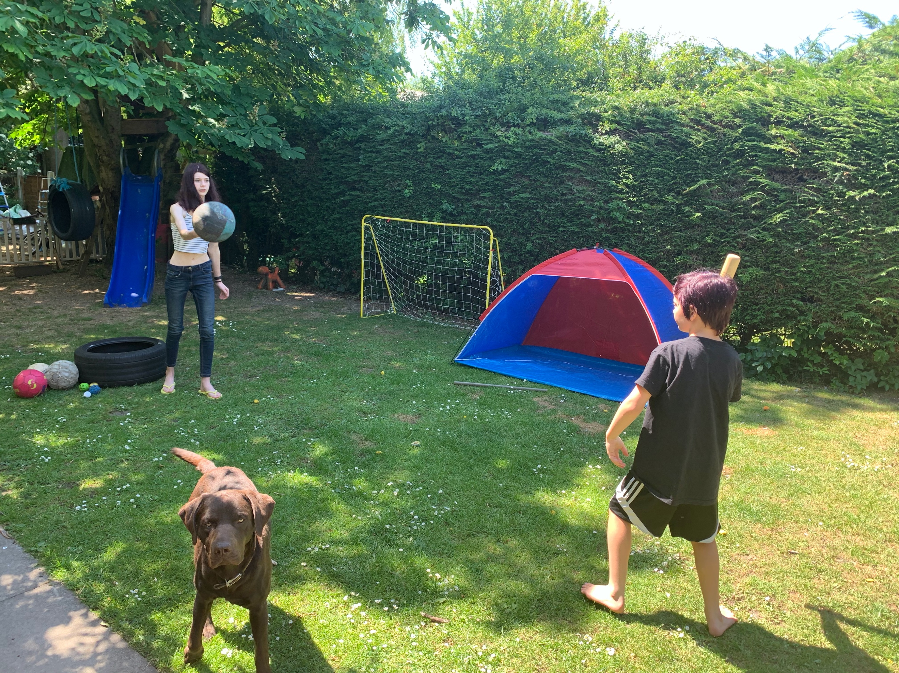

How to score the game.

If the bowler catches the ball they put the ball in the bucket.
If the batter hits the ball but the bowler fails to catch it that’s one point to the batter.
If the batter fails to hit the ball then that’s a point to the bowler and they put the ball in their bucket

- When all the balls have been thrown, count up how many the bowler and batter has. The one with the most balls wins.

- Swap over and repeat

- For a trick, throw a blown egg.

