Meerkats (Y3) Weekly Plan
Week Beginning 8th June 2020
Hi Meerkats,

Here we are, the 2nd half of the Summer term. Our main focus for this half term is all about the body. It is mainly Science and Design Technology focused but we will add in some Art, History and Geography as well. I’m going to set you a DT project the same as what we would do in school. I’ll tell you all about it below, it will say the same each week - it is up to you how much you do each week to be able to complete the project.

I’ve decided to leave the reading eggs and Mathletics open so you can complete them at your own pace and choose topics you feel you need to practise or learn more about. Please e-mail me if you have any questions and to send me some of your amazing work that I know you are doing.

Missing you all. Either this week or next week myself or Mrs Atkinson will be giving you a call to have a chat, tell us all about the exciting things you have been doing with your families and remember to let us know how you have shown you have cared, grown and shone this year in school so we can add them to your reports.

Mrs Catterall x

English  Daily reading of a variety of reading material, listening to online stories, practising the spelling of year 3 / 4 statutory words etc. |  | Maths  Daily practise of times tables using suggested websites, games, activities. Practise formal methods of + - × ÷ (methods on blog)
 | Focus theme: Characters, characters!  This week is all about exploring characters from different stories and finding  new vocabulary. At the end of the week, decide which character is your  favourite!  When following links online, parents should monitor that children are  remaining on that page only and are keeping safe online.  PLEASE SEE ADDITIONAL PLANNING SHEET | Focus: Equivalent Fractions.  This is new learning for the children.  Give it a go, there is a video and matching worksheets for 4 days. If you get stuck don’t worry I have added some additional fraction activities which cover learning already done in class which you can have a go at and you can keep practicing the 4 number operations using 3 digit numbers.

Choose when you do these activities over the week.
Science | The Human Body – The skeleton Week 1  This week you need to complete the tasks in 2 parts – (no cheating).  Task 1  On the blank body outline you need to draw on the bones inside your body, think about what shape they are, how big they are, the position of them. (an alternative, depending on the weather and with permission, you might draw around your body with chalk outside or on a roll of paper to make a life size drawing of your bones)  Task 2  Now you can look at the other resources to find out more about the Skeleton. There are a couple of sheets which have diagrams of the skeleton. you need to research what the names of your bones are, they have some common names but it is also fun to find out the scientific names. There are 3 options, Label the bones of the skeleton, Page 1 tells you where the bones are and the words at the bottom to match, page 2 tells you the words but you have to be able to label it yourself (Page 3 is the answers, no peeking!). The 3rd option is to print the skeleton only page and do all your own research to label the skeleton.  There are also 2 other fun tasks to do. Look at the pictures of X-rays and see if you can work out which part of the body they are from and you could have a go at the measure your skeleton activity.
DT Project  This will take you the rest of this half term to complete. | Linkages and Levers  Last year with Mrs McLennan you had a go at making some different levers. This year you are going to use this knowledge to create a moving person / animal / creature. I’m going to give you the different instructions for the levers, you will need to select which levers you want to make and how you will put them together to make your moving project. If we were in class we would link this to the story of The Iron Man and you would be able to make one of your own. You can use this idea or one of your own.  To start your project do some research about different linkages and levers. When are they used in real life? How do they work? Make a fact page or PowerPoint about what you discover. You might have some real examples of levers in action in your house.  Look through the PDF which goes through the different linkages and levers you can make and an example of a board children in the past have made showing 4 of the different ones you could make. The last page show you some examples of the Iron men the children created. The mechanisms are all hidden behind. Now make and explore and create your own moving project.
Art | This half term we are focusing on drawing and shading. Have a look at the PowerPoint and then practice you shading techniques.
History | Anglo Saxons and Vikings.  These periods of History came after the Stone Age, Bronze Age, Iron Age and Romans. Find 5 key facts about each period of time. If you send me your facts I can add them to the class blog for your friends to see as well.
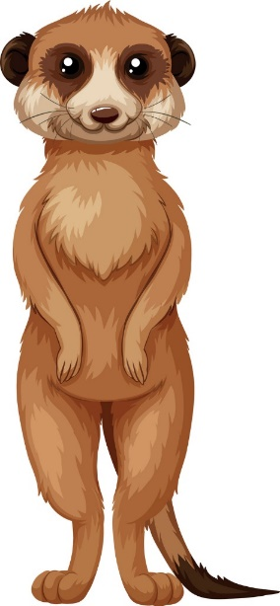
You still have your booklets so if want to do some more pages in those that is fine.
Have a good week, I’ll look forward to seeing some of what you have been up to.

Take care Marvellous Meerkats.
Mrs Catterall and Mrs Atkinson x

