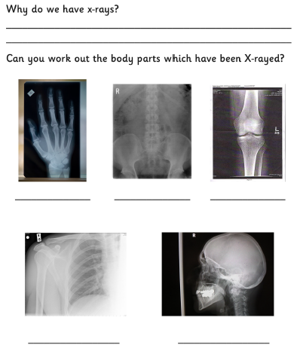
X- Ray
Have you ever had a X-ray, what was it of?

