**Welcome back Meerkats**

Over the past few months we have not been in school because of the coronavirus. During this time, you have been doing your school work at home this has been to help keep everyone safe. This has been a bit different, at times it might have been fun and sometimes it might not. Children in year 3 can come back to school, this is Ok. Mrs Catterall and Mrs Atkinson are really looking forward to seeing you all and we will help keep everyone safe.

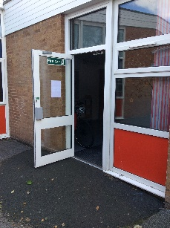When we come back to school some things will be different. Don’t worry we will tell you all about it and we are there to help you all throughout the day.

As you know some children will be going into the year 3 classroom with Mrs Catterall and some will be going into the year 4 room with Mrs Atkinson. You will all come into school through the doors like you would do normally.

We won’t be using our pegs so you walk straight into the classroom with all your things. Your books will be on a table so you’ll know where to sit.

The classrooms are set out a bit differently as we have to remember to keep our distance with each other. This is great as it means you get a whole table to yourself. You will sit at one side of the table and your bag, lunch box and water bottle will go at the other side.

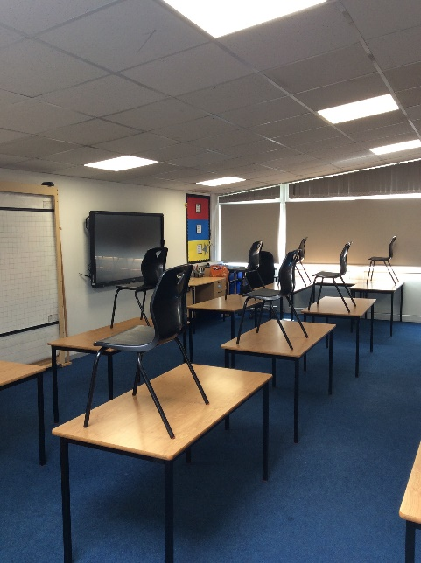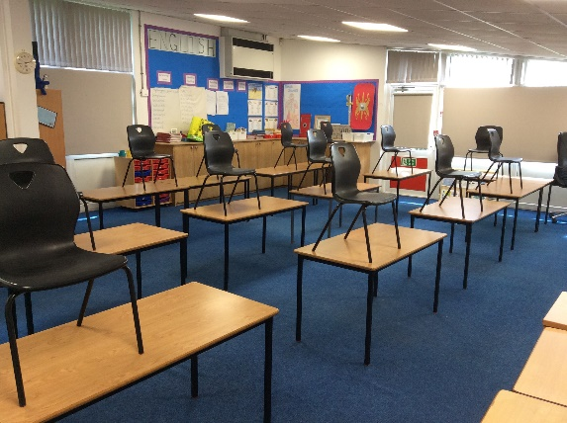

Mrs Catterall and Mrs Atkinson have a special place where they have to stand in the room, when you will arrive you will see where the tape is on the floor – this is the teacher space and not for children to enter.

When we are all in our classroom this is our special bubble and we stay together throughout the day.

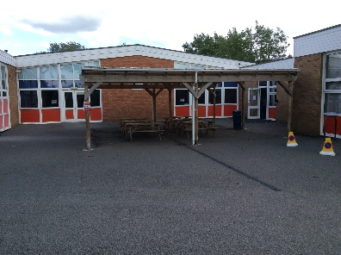Our lunchtimes and playtimes will be at different times of the day and there are only certain parts of the playground we can use. We will tell you all about it on Monday.

Just like you will have been doing at home, we will all need to wash our hands regularly. We now have a sink in our classroom to help us do this easily.

Although we have to remember to not get too close to each other we are going to have lots of fun back in school.

What you need to bring

* Water bottle
* Packed lunch
* Pencil case with colouring pencils/felt tips, pencil rubber etc. (this will stay at school)
* School bag (this will stay at school)
* A hat to wear in the sun

**We are so excited to see you on Monday.**

**Have a good weekend**

**Mrs Catterall and Mrs Atkinson.**