Hello Elephants, it will soon be time for our class to return to school and we have been busy getting everything ready .
Mrs Woolley and I have enjoyed talking to you on the phone and hearing about all of the learning you have been doing and the new skills you have been learning. The last few months have been a very different time for all of us and having to do our work at home will have been fun for some of us and a challenge for others. By being superstars and staying at home you have played a really important part in helping the country bring coronavirus under control.
The time has come now for us to safely return to school on Monday July 6th. You will be in 2 bubbles of 15. Bubble 1 will be in our classroom with Mrs Woolley and Bubble 2 will be with Mrs Fletcher in the top part of Kelly’s club.
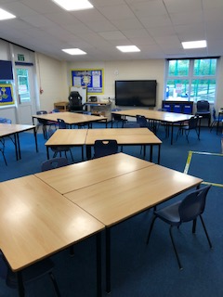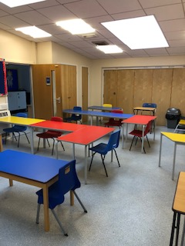
When you come into the rooms you will be asked to sit at a table, this will be your table for the whole time we are in school. Your books will be on the table ready for you.
The first thing you will be asked to do on Monday morning will be to put your book bag (SCHOOL BOOK BAGS ONLY) on your table and then to wash your hands. Once you have done that Mrs Woolley and Mrs Fletcher will stand in our places and explain the new routines, we have to keep us all safe. We will show you our playing out area near the ball cage, explain our toilet times and how lunchtime will work.
We will not be using the cloakrooms, everything you bring will be staying with you.
What you need to bring
- Water bottle
- Packed lunch – only if you are not having a lunch provided by school
- Pencil case with colouring pencils/felt tips, pencil rubber etc. (this will stay at school)
- School bag (this will stay at school) – all the books we will be working in will be placed in this bag so it must be the school book bag in order for them to fit.
- A hat to wear in the sun
- Sun cream
- Reading Books – these will be placed in a box in the classroom.
- Any home learning you would like us to look at.

We are looking forward to seeing you on July 6th.
Mrs Fletcher and Mrs Woolley

