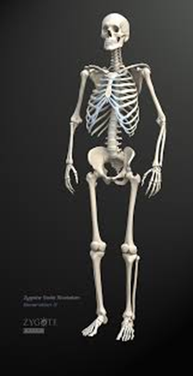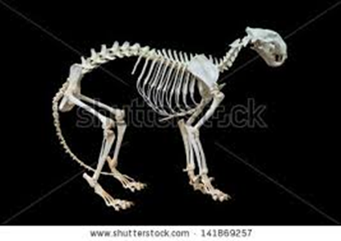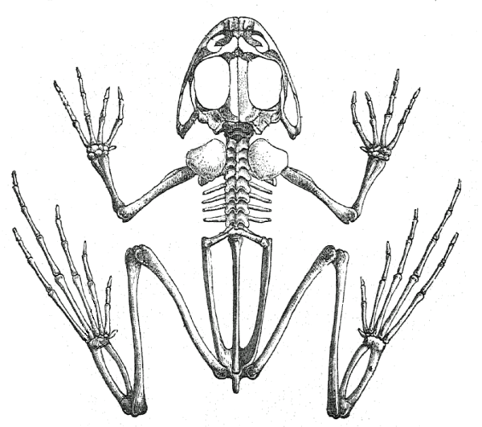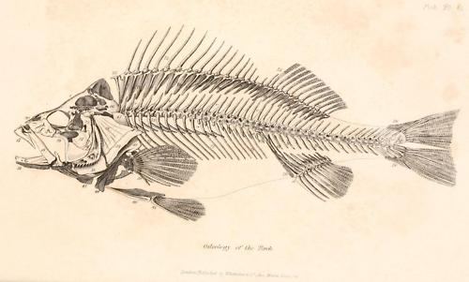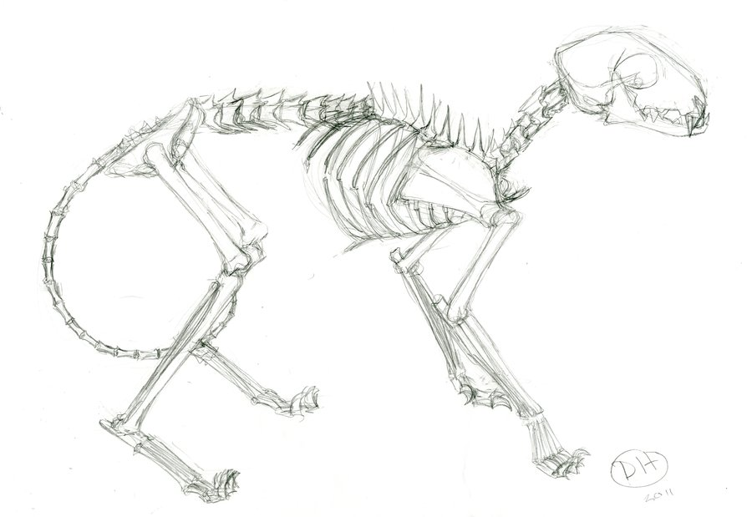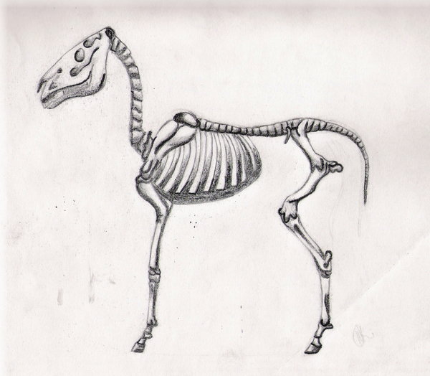
What do you know?
Why do humans and animals have muscles?
What is a vertebrate?

What is an invertebrate?
Can you write the name of the animals that these skeletons belong to?
What bones protect the heart and lungs?

What protects the brain?
Can you name some bones in
the human body?
Why do humans and animals have a skeleton?
1.

2.

3.

The skeleton
Animals and humans

