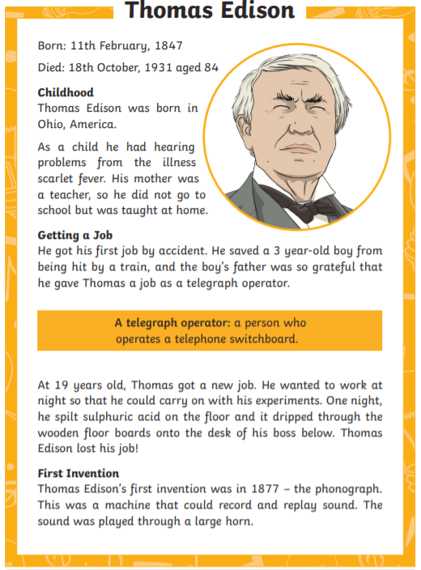
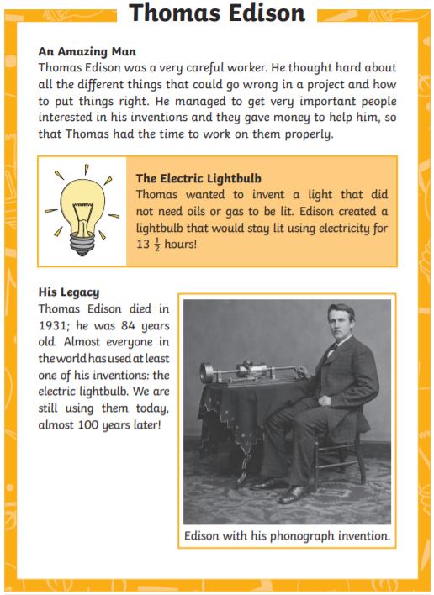

Thomas Edison Questions
Answer the followin questions in as much detail as you can using full sentences.
- Why did Thomas Edison have hearing problems?

- How did he get his first job as a telegraph operator?

- How did his boss find out he was doing experiments while he was at work?

- What was the name of the invention that could record sound?

- What did his electric lightbulb not need to work, that other previous lights did?

- Name one quality in Thomas Edison’s character that made him a great invnetor?

- How old was Thomas when he died?

- Why should we be grateful to Thomas Edison?

