Year 6 Autumn 1st half term
KQ: What did the Greeks achieve and how did they influence the western world?  - When did the Ancient Greeks live?  - How has democracy developed from the Ancient Greeks to today?  - What w ere the Ancient Greek Olympic games like?  - Do stories from Ancient Greece still hold significance today?  - What happened in the Battle of Troy? |  | Science:  KQ: What are evolution and inheritance?  - Do offspring always closely resemble their parents?  - How have living things changed over time?  - How are animals and plants adapted to suit their environment in different ways?  - How do fossils provide information about living things that inhabited the Earth millions of years ago?
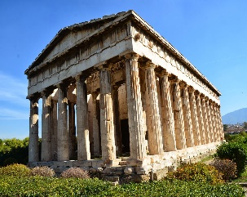
This Photo by Unknown Author is licensed under CC BY-NC-ND
Can you find the meaning of these key vocabulary words?

origin | BC/BCE | AD/CE | Timeline
chronological | cultural | social | political
sources | empire | conquer | kingdoms
civilisation | ancient | modern | legacy

Geography:  No focus this term , however we will look at maps of where the civilisation of Ancient Greece was in comparison to modern Greece. | RE: Hindu God  KQ: Is there one journey or many?  - What makes us human? How do humans change during the journey of life?  - Is there one journey or many?  - How do the rites of passage prepare Hindus for each new stage of life?  - How have I changed during my life so far? Am I ready for future changes? |  | - PSHE: Jigsaw Being Me In My World  - KQ: Do you understand your place in the world/school/community?  - What are my success?  - What are my dreams and goals and how will I achieve them?  - What are the universal rights of all children?  - Do all children have these rights?
Computing: 3D modelling with a specialist teacher  Music: Advanced rhythms: building a sense of pulse in compositions  PE: Play Leaders | French: Sports and Hobbies  - To learn new nouns for sports  - To use j’aime jouer (infinitive) to say what sports I like to play  - To recap the different endings of infinitives  - To read descriptions about French footballers  - To learn about a popular sport in France and a French athlete  To learn the subject pronouns and see the formal layout of a verb table (jouer) |  | DT: Food: Come dine with me  - Find a suitable recipe for their course.  - Record the relevant ingredients and equipment needed.  - Follow a recipe, including using the correct quantities of each ingredient.  - Write a recipe, explaining the process taken.  - Explain where certain key foods come from before they appear on the supermarket shelf.

