Year 5 Spring 1st Half Term
Space to write an overview for the half term – Tribe and year specific – trips / visitors / Special days / enterprise / assembly etc
History: Earliest Civilisations – Indus Valley  KQ: Why  - Where was the Indus Valley civilisation located and when in time?  - What were the most significant sites of the Indus Valley civilisation?  - How was the Indus Valley Civilisation discovered?  - How can we find out what life was like in an Indus City?  - How did the Indus Valley Civilisation end? |  | Science: Living things and their habitats  KQ: What are the differences in life cycles of plants compared to animals?  - Can you describe what a life cycle is?  - Can you describe the differences between the life cycles – amphibians, an insect and a bird?  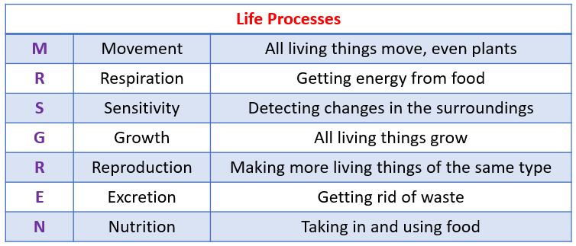  - How do plants reproduce?  - How do mammal reproduce?  - What is the life process of reproduction of some animals?
Can you find the meaning of these key vocabulary words?

Life Cycle | reproduction | genes | inherit | amphibian | Bird
Insect | mammal | MRSGREN
seal | citadel | Mohenjo-Daro | Harappa | Soapstone | Ghaggar-Hakra

 | RE: Hinduism  KQ: What might a Hindu learn from stories about Krishna?  - What are they key vision and values of Hinduism?  - What is incarnation?  - Who are nine incarnation of Vishnu?  - What is the importance of Krishna incarnation?  - Can I recall stories about Krishna?  - Why is Krishna considered one of the most importance incarnation of Vishnu? |  | PSHE: Jigsaw - Dreams and Goals  KQ: What does the future hold for me?  - What future dreams do we have?  - What is the importance of money?  - What goals to I have for my career and how to get there?  - Supporting others through charities
Computing:  - Sharing information  Art:  - Every picture tells a story: ink drawing  Music:  - South and West Africa: chords and tuned instruments  PE:  - Outdoor adventurous  - Dance | DT: Digital World  Monitoring devices  KQ: What is the best design for an animal monitoring device?  - What is a monitoring device?  - Why are monitoring devices essential?  - What electric components are need to measure an animals temperature?  - What must our program do to be successful?  - How do debug your program? |  | French: Sports and Hobbies  To learn new nouns for sports  To ask for and give opinions about sports  To say what hobbies I do  To learn about a popular sport in France and learn about a French athlete  To learn the pronouns  To learn the 6 verb endings and see the formal layout of a verb table (jouer)

