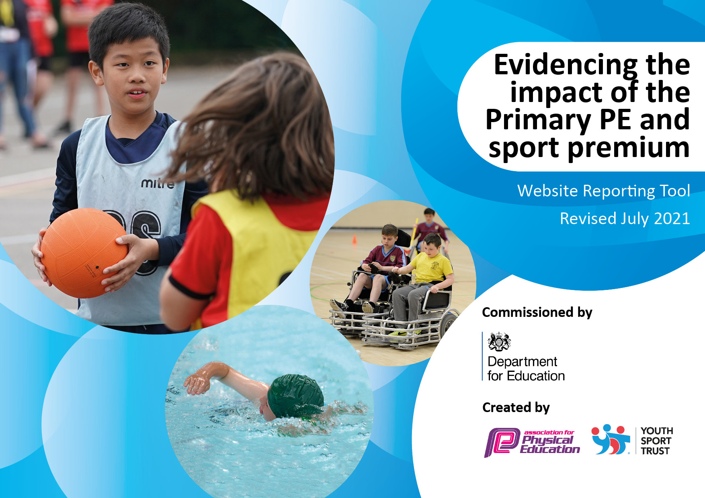
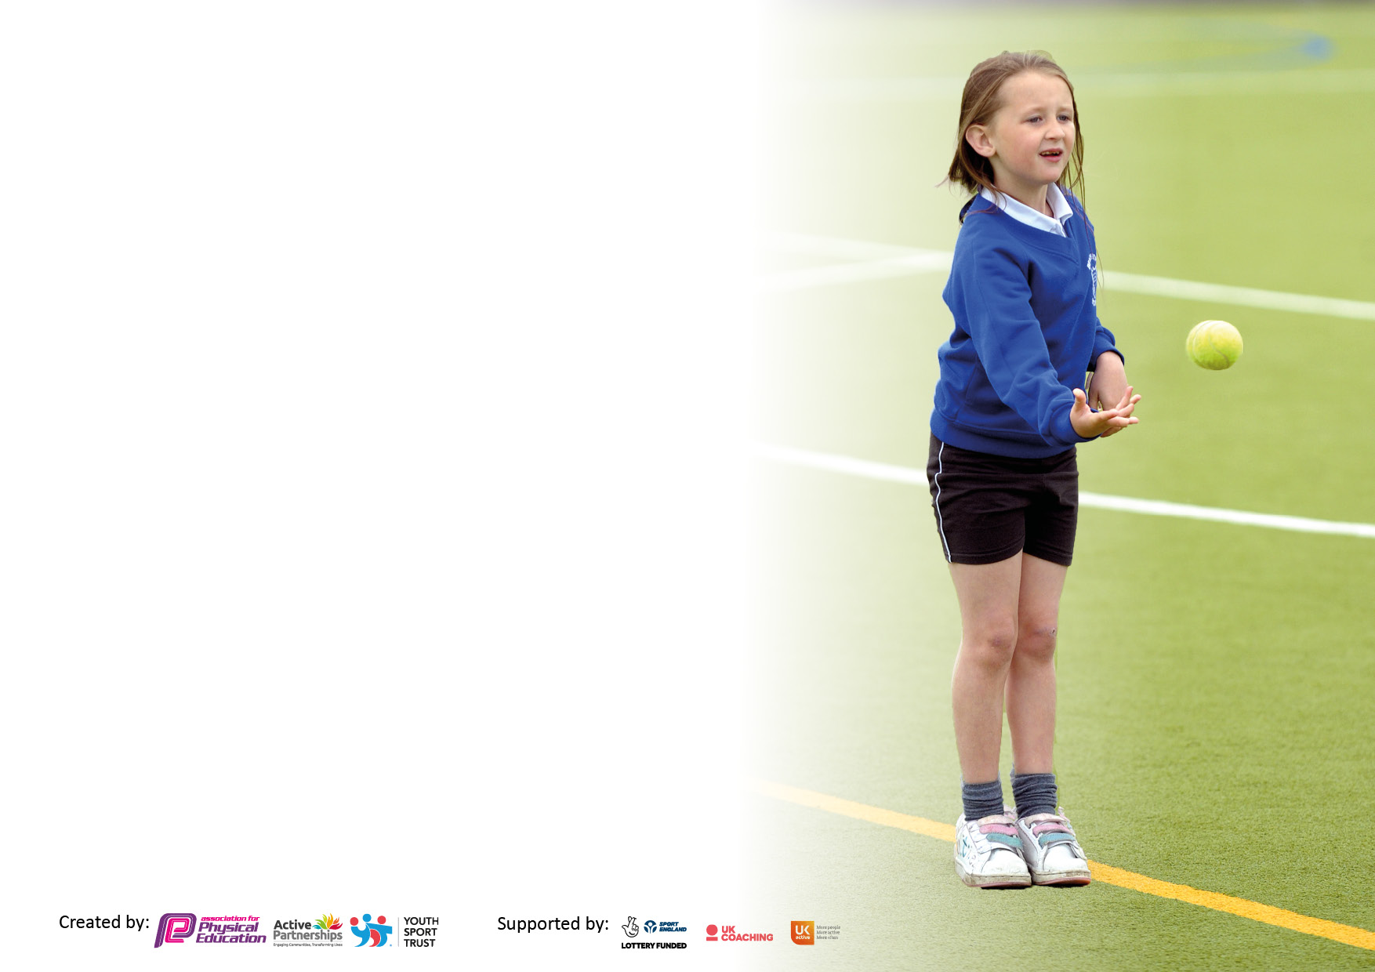

It is important that your grant is used effectively and based on school need. The Education Inspection Framework makes clear there will be a focus on ‘whether leaders and those responsible for governors all understand their respective roles and perform these in a way that enhances the effectiveness of the school’.

Under the Quality of Education Ofsted inspectors consider:
Intent - Curriculum design, coverage and appropriateness
Implementation - Curriculum delivery, Teaching (pedagogy) and Assessment
Impact - Attainment and progress

To assist schools with common transferable language this template has been developed to utilise the same three headings which should make your plans easily transferable between working documents.

Schools must use the funding to make additional and sustainable improvements to the quality of Physical Education, School Sport and Physical Activity (PESSPA) they offer. This means that you should use the Primary PE and sport premium to:

- Develop or add to the PESSPA activities that your school already offer
- Build capacity and capability within the school to ensure that improvements made now will benefit pupils joining the school in future years
- The Primary PE and sport premium should not be used to fund capital spend projects; the school’s budget should fund these.

Pleasevisitgov.ukfortherevisedDfEguidanceincludingthe5keyindicatorsacrosswhichschoolsshoulddemonstrate animprovement.Thisdocumentwillhelpyoutoreviewyourprovisionandtoreportyourspend.DfEencouragesschools to use this template as an effective way of meeting the reporting requirements of the Primary PE and sport premium.

We recommend you start by reflecting on the impact of current provision and reviewing the previous spend.

Schools are required to publish details of how they spend this funding, including any under-spend from 2019/2020, as well as on the impact it has on pupils’ PE and sport participation and attainment. All funding must be spent by 31st July 2022.

We recommend regularly updating the table and publishing it on your website throughout the year. This evidences your ongoing self-evaluation of how you are using the funding to secure maximum, sustainable impact. Final copy must be posted on your website by the end of the academic year and no later than the 31st July 2022. To see an example of how to complete the table please click HERE.
Created by: Supported by:

Details with regard to funding
Please complete the table below.

Total amount carried over from 2021/2022 | £ 0
Total amount allocated for 2022/23 | £17,790
How much (if any) do you intend to carry over from this total fund into 2022/23? | £ 0
Total amount allocated for 2022/22 | £17,790
Total amount of funding for 2022/23. To be spent and reported on by 31st July 2023. | £17,790
Swimming Data
Please report on your Swimming Data below.

Meeting national curriculum requirements for swimming and water safety.

What percentage of your current Year 6 cohort swim competently, confidently and proficiently over a distance of at least 25 metres?  N.B. Even though your pupils may swim in another year please report on their attainment on leaving primary school at the end of the summer term 2023.  Please see note above | 100%
What percentage of your current Year 6 cohort use a range of strokes effectively [for example, front crawl, backstroke and breaststroke]?  Please see note above | 93%
What percentage of your current Year 6 cohort perform safe self-rescue in different water-based situations? | 93%
Schools can choose to use the Primary PE and sport premium to provide additional provision for swimming but this must be for activity over and above the national curriculum requirements. Have you used it in this way? | No

Action Plan and Budget Tracking
Capture your intended annual spend against the 5 key indicators. Clarify the success criteria and evidence of impact that you intend to measure to evaluate for pupils today and for the future.

Academic Year: 2022/23 | Total fund allocated:£17,790 | Date Updated: July 2023
Key indicator 1: The engagement of all pupils in regular physical activity – Chief Medical Officers guidelines recommend that primary school pupils undertake at least 30 minutes of physical activity a day in school |  |  |  | Percentage of total allocation:
 |  |  |  | 39% + £1500 additional funding
Intent | Implementation |  | Impact
 | Make sure your actions to achieve are linked to your intentions: | Funding allocated: | Evidence of impact: what do pupils now know and what can they now do? What has changed?: | Sustainability and suggested next steps:
Improve health and fitness of all pupils.  Increase the participation of children during lunchtime and breaks  Develop wellbeing opportunities to ensure children take healthy lifestyle choices in order that they remain mentally sound. | Walking bus – encourage children to walk to school an increase their daily exercise  Use the daily mile track to improve fitness.  Daily mile track to use the daily mile track to increase daily minute intake including different equipment at stations  Provide external Play makers training for Y5  Children in Y5 provide activities for their peers during play and lunchtimes  Welfare to actively encourage the children to be active at lunchtimes through a range of structured games and activities in different zones around the playground.  Specific Welfare staff to be employed to supervise and run sports activities  Relax kids interventions with children who are anxious in relation to sport and improve general wellbeing and educate about healthy living. | £1800  2 x ½ hour cost of Teaching assistants to organise daily walking bus  £500 sports equipment at different stations  £250 for coach for the day  £150 additional costs for 2 hours of training  £500 for additional games equipment  £3290 yearly cost  £2000  Specialist Relax kids  Total £8390 | Update of walking bus is an average of 30 children daily.  These children are taking part in 15 minutes of exercise everyday before school starts. Equally the impact on other children’s health by removing an average of 20 cars worth of pollution from the school gates daily.  From surveying classes, children are more positive about using the track as there is equipment at each station and equipment to use on the track. Children are increasing their participation in sports  All Y5 children have taken part in providing games and activities for different year groups throughout the school year. Children supported by welfare staff have implemented a range of games from the book of games.  Total of 26 children received specialist support. 100% of the children rated sport and healthy choices as an improvement made through the programme 95% of the children’s teachers found that the children had improved reliance in sport and an improved positive mindset to allow them to overcome issues. | Continue to promote walking to school, continue to provide a daily walking bus and encourage other children and parents to walk or cycle to school.  Children have a greater knowledge about activities they can do to promote their fitness. On going adapting the equipment and tasks around the track  Children have grown in self confidence in providing leadership to others and the uptake to these activities along with the games provided by welfare staff is 70%  Monitor target children in the next current academic year. Identify new children that would benefit from the programme and implement
Key indicator 2: The profile of PESSPA being raised across the school as a tool for whole school improvement |  |  |  | Percentage of total allocation:
 |  |  |  | 9%
Intent | Implementation |  | Impact+
Your school focus should be clear what you want the pupils to know and be able to do and about  what they need to learn and to  consolidate through practice: | Make sure your actions to achieve are linked to your intentions: | Funding allocated: | Evidence of impact: what do pupils now know and what can they now do? What has changed?: | Sustainability and suggested next steps:
Team teaching with specialist teachers and coaches across all three Key Stages.  Ensure the website is kept fully update  Inform parents about opportunities for family active activities | Training for PE lead  Training for all staff in tennis and cricket  Monitor current assessment system to assess children across the areas of PE and Sport and the impact it has on progression  . ½ termly meeting with sports leaders  Send a termly update to parents in the form of a newsletter with photos, sporting outcomes etc. local clubs. | £600 for release time for P.E. lead to complete tasks  £500 Primary Passport App subscription  PE subject lead release time  Supply cover £500  Total £1600 | Improved profile of PE and sports throughout  Assessment being used effectively by teachers to track progression and inform planning.  Parents are informed about outside sporting opportunities for their children and themselves. | Continuation of competitive sports in the next academic year, taking part in more with other schools in a range of sports.  Ensure all staff engage in attending competitive sports events not just the subject lead.

Key indicator 3: Increased confidence, knowledge and skills of all staff in teaching PE and sport |  |  |  | Percentage of total allocation:
 |  |  |  | 17%
Intent | Implementation |  | Impact
Your school focus should be clear | Make sure your actions to | Funding | Evidence of impact: what do | Sustainability and suggested
what you want the pupils to know | achieve are linked to your | allocated: | pupils now know and what | next steps:
and be able to do and about | intentions: |  | can they now do? What has
what they need to learn and to |  |  | changed?:
consolidate through practice:
CPD through team teaching with specialist sports coaches, cricket, tennis.  Dance is a focus this year to improve | All teachers will have specialist teacher instruction in either cricket or tennis for their class.  Teachers observe the coaches delivering lessons to ensure there is a lasting legacy in our chosen sports  Specialist teacher to deliver teaching to all classes | £2000  £1000  Total Spent  £3000 | Teacher’s questionnaire responses indicated that they have found observing and teaching alongside a specialist coach a positive experience with 100 % of them stating it has improved their subject knowledge and teaching skills.  All children took part in in a dance festival day learning a new dance each.  3 classes had a ½ term of specialist dance teacher. Thy then performed their dances to the whole school. Teacher’s report that the majority of children actively took part and enjoyed | Improved teacher subject knowledge in cricket and tennis and improved confidence in delivering a series of dance lessons accumulating in a complete final dance
Key indicator 4: Broader experience of a range of sports and activities offered to all pupils |  |  |  | Percentage of total allocation:
 |  |  |  | 12%
Intent | Implementation |  | Impact
Your school focus should be clear | Make sure your actions to | Funding | Evidence of impact: what do | Sustainability and suggested
what you want the pupils to know | achieve are linked to your | allocated: | pupils now know and what | next steps:
and be able to do and about | intentions: |  | can they now do? What has
what they need to learn and to |  |  | changed?:
consolidate through practice:
Offer a wider range of extra-curricular clubs for all pupils.  Develop frisbee golf | Organise a full timetable of extracurricular sports clubs throughout the year to included: Football, Tag Rugby, running, circuit training, cricket, dodgeball, tennis, rounders, athletics  Purchase and set up a course on the school field | £1500 for coaches  £500  Total spent £2000 | A total of 84 children from Y1 – Y6 took part in after school clubs delivered by coaches. | Continue to offer a range of extracurricular clubs in a range of different sports  Frisbee to be set up next academic year.

Key indicator 5: Increased participation in competitive sport |  |  |  | Percentage of total allocation:
 |  |  |  | 23%
Intent | Implementation |  | Impact
Your school focus should be clear | Make sure your actions to | Funding | Evidence of impact: what do | Sustainability and suggested
what you want the pupils to know | achieve are linked to your | allocated: | pupils now know and what | next steps:
and be able to do and about | intentions: |  | can they now do? What has
what they need to learn and to |  |  | changed?:
consolidate through practice:
Take part in South Ribble SSP competition programme in a range of sports, including girl’s football and inclusion.  Inclusion: aim for all young people / pupils to represent school over the course of the year  Track female participation in competitive sports and encourage through positive role models | SSP enter competitions and events enter an increased inter-school,  intra-school competitions arranged by sports specialist at lunch time.  In our four key sports develop links with other clubs and arrange fixtures.  As many children as possible in KS2 will represent school through competitions or inclusion festivals over the course of the year.  Monitor grouping of extra curricular activities | £500 Specialist Sports coach to run lunchtime intra school sports  SSP cost £3500  Total Spent  £4000 | School entered a number of different competitions against other schools, a total of 44 different children took part in inter school events.  Weekly intra school football took place for two terms on Friday lunch time.  Intra school cricket took place for one term.  Intra school football tournament took place after school 72 children involved | Increase the participation of females in competitive sport, build on the popularity of girls football, and develop a girls football team along with Blackburn Football Club.  Sign up for more South Ribble SSP competitive sports.

Signed off by
Head Teacher: | Julie Brown
Date: | July 2023
Subject Leader: | Iain Pearson
Date: | July 2023
Governor: | J Barnes
Date: | July 2023

