HOTHERSALL LODGE FIELD STUDY CENTRE
PERSONAL EQUIPMENT LIST

All the activities will be outside so students will need plenty of warm clothes especially in winter. Clothes will get dirty and wet. More clothes are needed for a week long course.
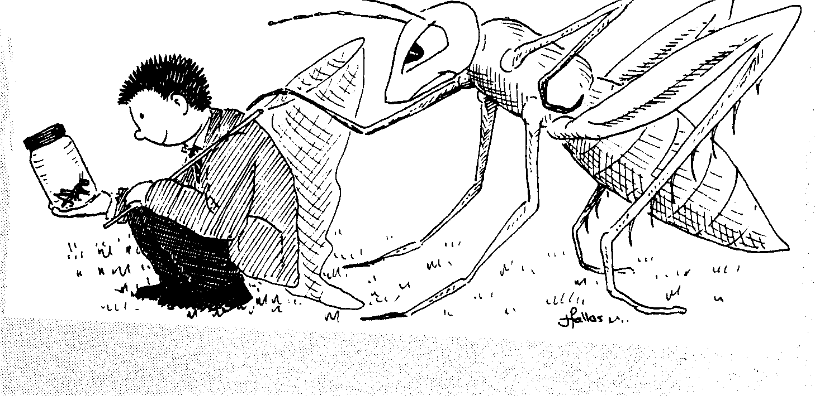



The following list
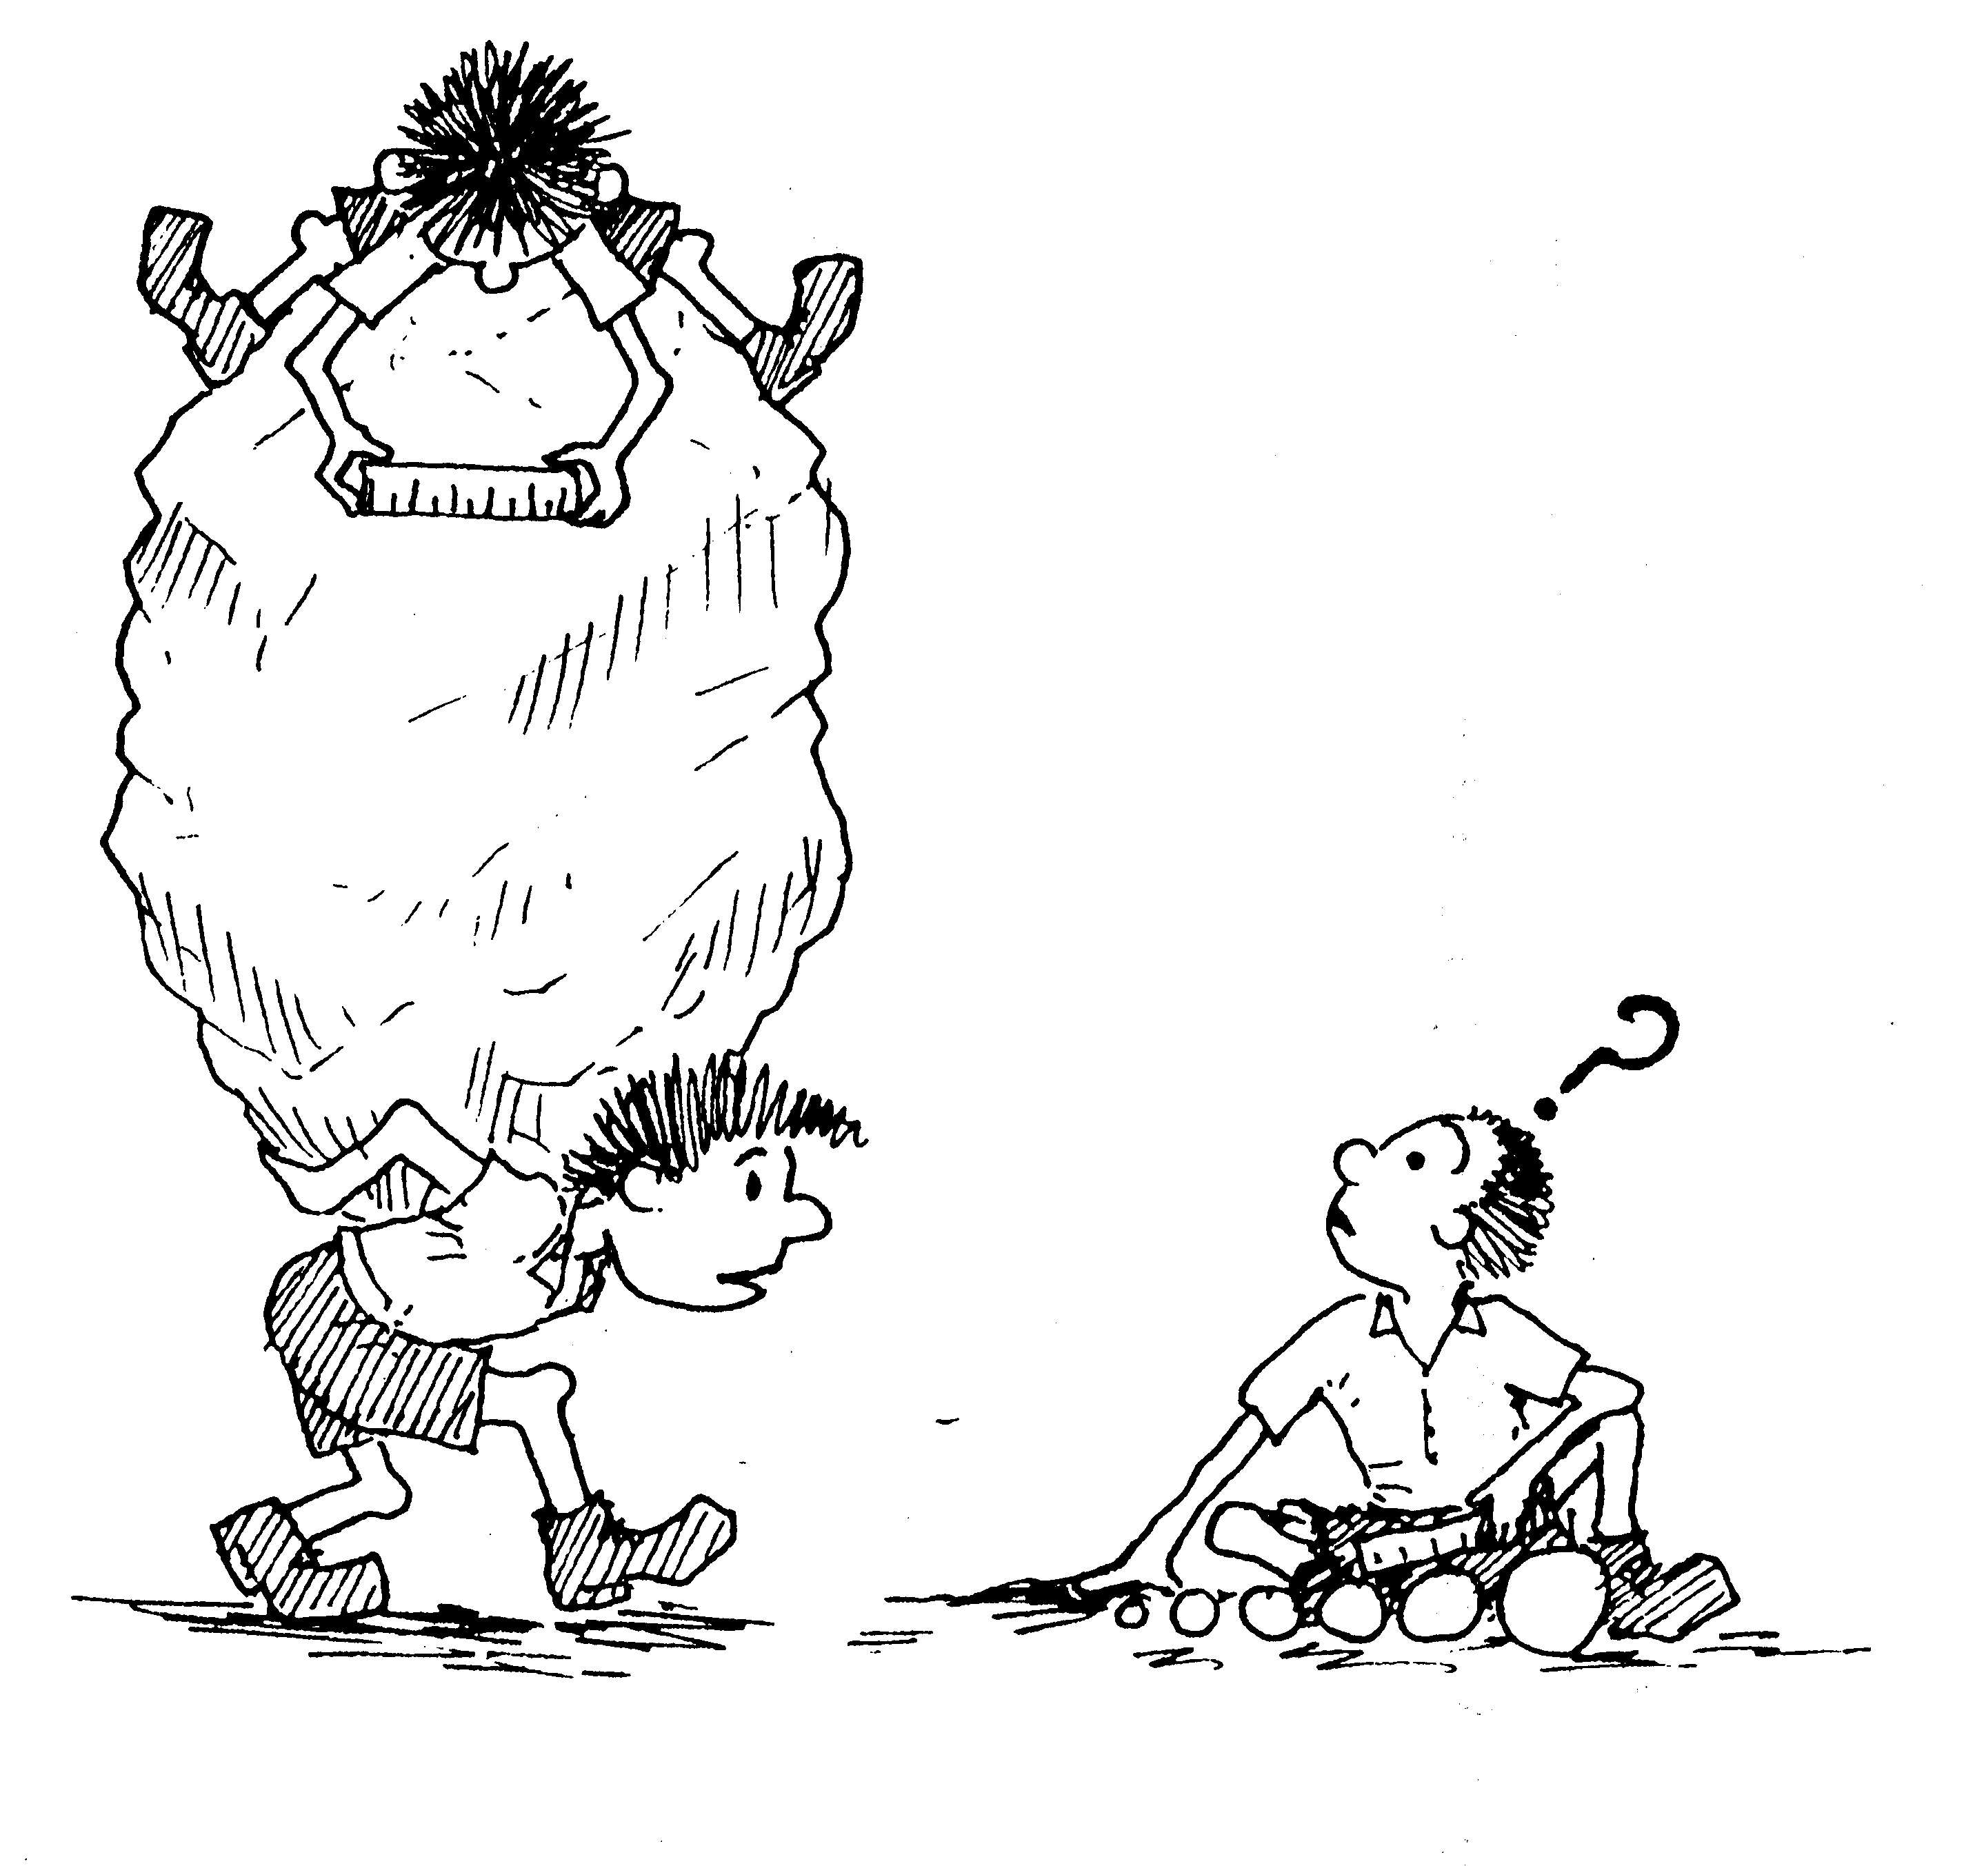
is suggested as a guide:

Several T-shirts or long sleeved tops.
Old thick jumpers or fleeces
Old tracksuit bottoms or similar (not jeans for comfort and safety reasons)
3 pairs of shoes, 1 pair for indoors, 1 pair for outdoors and 1 pair for water activities that may get wet if you are doing canoeing.
Night clothes
Underwear
Toiletries, Tooth brush and toothpaste, soap, shampoo etc
Towel
Plastic bags for wet clothes
Hat and gloves for cold weather
Shorts, sun cream, a hat and a plastic drinks bottle for hot weather
Socks, several thick pairs and several normal ones
Casual clothes for evening wear
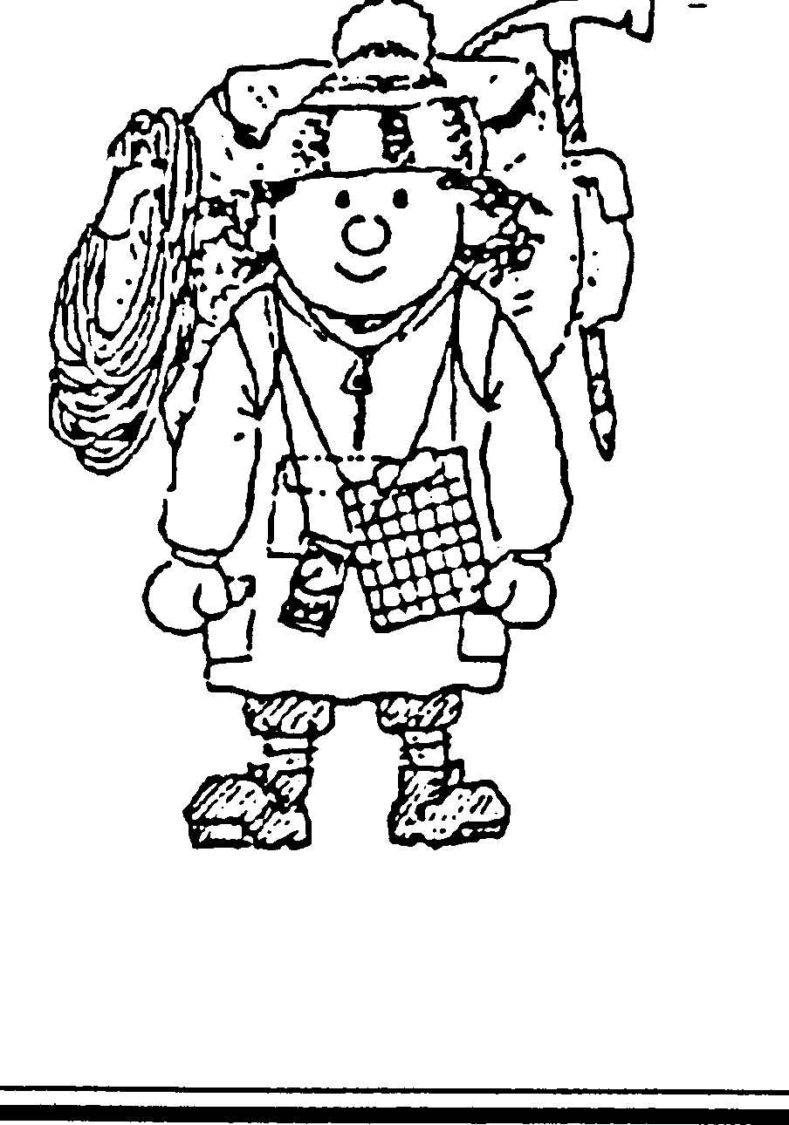

If you have the following bring them with you,
otherwise they will be provided.

Walking boots
Wellington Boots
Waterproof jacket
Waterproof over trousers
Small rucksack

No one should need to buy anything for their visit.

Students attending revision courses only will not need some of the outdoor clothing.

DUE TO SMOKE DETECTORS IN THE BUILDINGS AEROSOL SPRAYS MUST NOT BE USED – DO NOT BRING THEM

STUDENTS NEED A PACKED LUNCH FOR THE FIRST DAY

IN SUMMER A HIGH FACTOR SUN CREAM IS IMPORTANT

