A selection of recommended authors and texts

EYFS

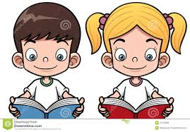

As part of our drive to develop a love of reading at Longton Primary School, we have compiled a list of suggested books and authors that can be used to guide parents and carers towards suitable and exciting books, appropriate for children of their age.

Tips to follow when reading with your child at home:
- Encourage lots of discussion about different books and authors, e.g. – “What do you like about the book?” “Which story did you like the most and why?”
- Find a quiet and calm place to spend some time sharing and enjoying books.
- Takes lots of trips to the library!
- Has your child understood what they’ve read? Ask them to re-tell the story and explain what’s happened during and after reading?
- Encourage independence – give lots of praise and rewards when your child chooses their own books and is keen to share and read them to/with you.
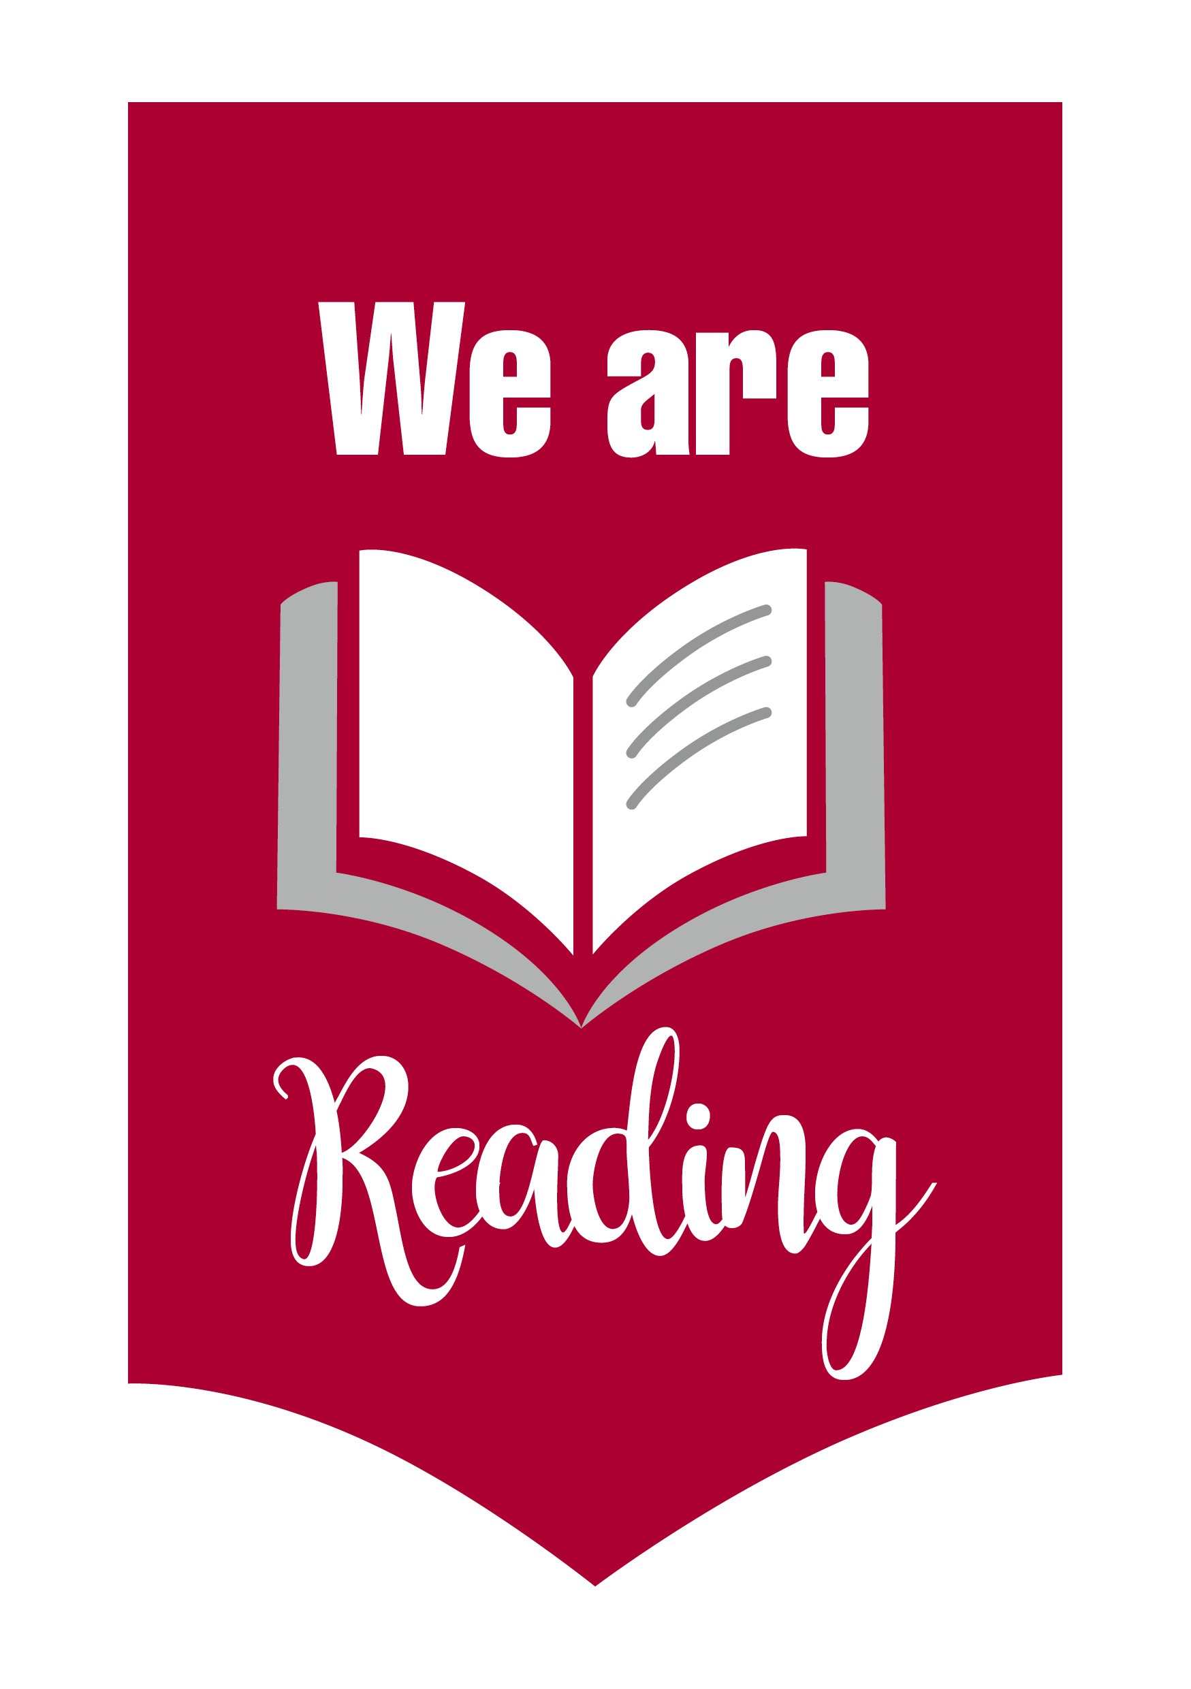
Winnie the Pooh | A A Milne
Each Peach Pear Plum  Peepo! | Allan and Janet Ahlberg
The Tale of Peter Rabbit | Beatrix Potter
Brown Bear, Brown Bear, What Do You See? | Bill Martin Jnr
The Little Red Hen | Byron Barton
Not Now, Bernard | David McKee
Handa’s Surprise | Eileen Browne
The Elephant and the Bad Baby | Elfrida Vipont & Raymond Briggs
The Very Hungry Caterpillar | Eric Carle
Where’s Spot? | Eric Hill
We’re Going on a Bear Hunt | Helen Oxenbury
The Owl Who Was Afraid of the Dark  The Tiger Who Came to Tea | Jill Tomlinson
The Gruffalo  The Gruffalo’s Child  Room on The Broom  What The Ladybird Heard  Stickman | Julia Donaldson & Axel Scheffler
My Friend Harry | Kim Lewis
I Will Never Eat a Tomato | Lauren Child
Stone Soup | Marcia Brown
The Rainbow Fish | Marcus Pfister
Goodnight Moon | Margaret Wise-Brown and Clement Hurd
Farmer Duck | Martin Waddell
Owl Babies | Martin Waddell and Patrick Benson
Once There Were Giants | Martin Waddell and Penny Dale
Where the Wild Things Are | Maurice Sendak
One Snowy Night | Nick Butterworth
Clifford the Big Red Dog | Norman Bridwell
There was an Old Lady who Swallowed a Fly | Pam Adams
Rosie’s Walk | Pat and Laurence Hutchins
Dear Zoo | Rod Campbell
Guess How Much I Love You | Sam McBratney and Garth Williams
Dogger | Shirley Hughes
Winnie the Witch | Valerie Thomas & Korky Paul
Elmer | David McKee
Giraffe’s Can’t Dance  Rumble in the Jungle | Giles Anreae
Traditional Tales such as The Three Little Pigs, Little red Riding hood, Goldilocks and the Three Bears, Jack and the Beanstalk

