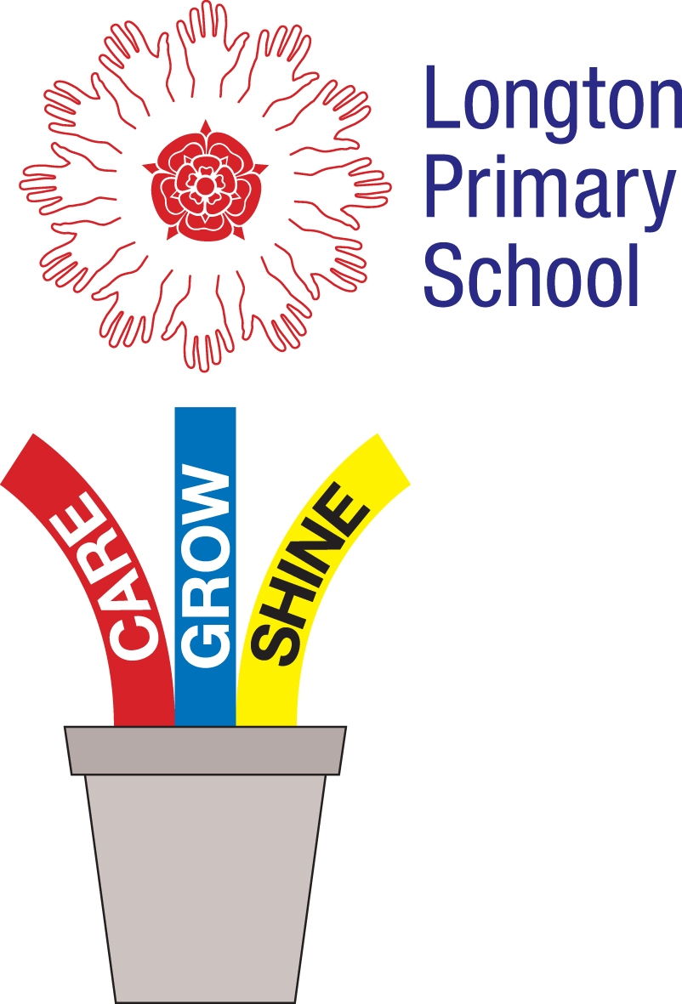

Longton Primary School Reading Challenge 2019
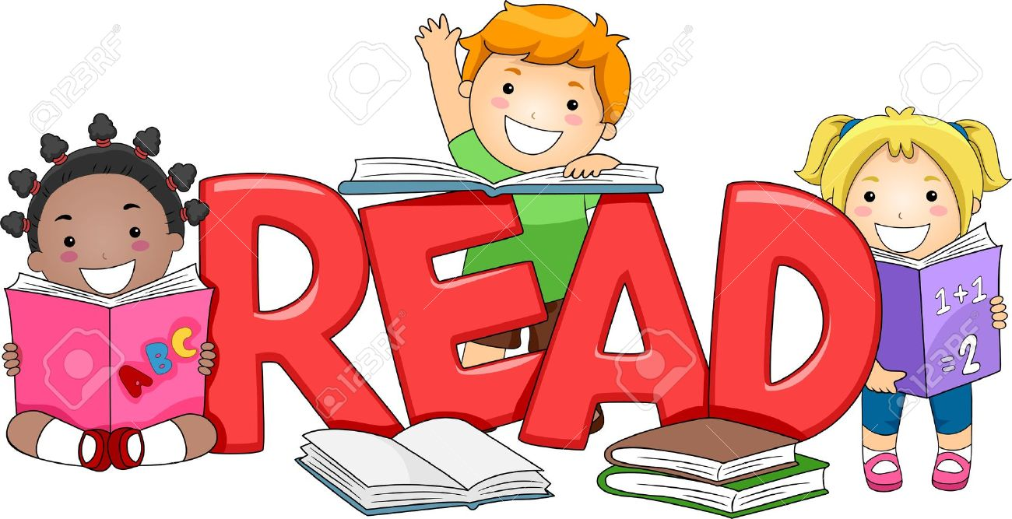

There is nothing better than reading a book for pleasure! We challenge you to read as many books as you can. These books should be books from the library or books from home that you enjoy. Please bring your sheet back after every 5 books you have read and be ready to have a chat about one of the books with an adult in school.

 | Title | Star Rating 1 to 5
1
2
3
4
5
BRONZE CERTIFICATE
6
7
8
9
10
SILVER CERTIFICATE
11
12
13
14
15
GOLD CERTIFICATE
16
17
18
19
20
★ ★ ★ SILVER STAR ★            ★                 ★
21
22
23
24
25
NON UNIFORM DAY

