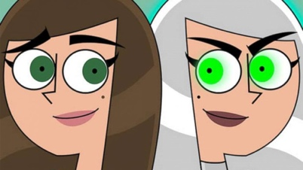
PORTRAITS

Has today’s visit to the Harris Museum and Art Gallery inspired you to want to find out more about Portraits ?

Here are some fiction and non- fiction books that you might like to read. You may be able to borrow them from your local Library. Visit https://www.lancashire.gov.uk/libraries-and-archives/libraries/ for more information about your local library services.
Faces by David Goodman and Zoe Miller

Faces are all around us, everywhere we look. On every page of this inspiring and imaginative book, you will find unusual and creative ways of making faces, using printing, collage, geometric shapes, and sculpture. Surprising details are revealed by lifting flaps, looking through holes, or turning the book upside down

Reading Age 7

Reading Age 5+

Katie and The Mona Lisa by James Mayhew

What makes the Mona Lisa smile? Katie wants to find out so she climbs into the Leonardo Da Vinci painting. But the Mona Lisa is not really feeling very happy so Katie tries to cheer her up . . . with disastrous results!

Reading Age 6 to 7
All About Faces – La Zoo

If you read this book you will have the face and its many parts explained to you in simple scientific terms.

Reading Age 4 to 5
What I Like About Me! – Allia Zobel Nolan

The children in "What I Like About Me," all different And, guess what? They love it. Some adore the fact that their braces dazzle and gleam, others feel distinguished when they wear their glasses. Still others wouldn't trade their big feet for a lifetime of free video games. This fun-loving book, which features entertaining flaps, pull tabs, and touch-and-feel elements such as embedded foil yarn, and more, proves to children that, in a world where fitting in is the norm, being different is what makes us special

Reading Age 2 to 5

Drawing Faces – Rosie Dickins

This book is full of ideas for drawing faces, portraits, caricatures and cartoons. It gives you step-by-step instructions, shows you how to use pencils, pens, pastels and paints and techniques including drawing on a computer, paper collage and printing. Includes QR links to download free images and watch video clips with drawing tips.
Reading Age 5 to 11

The Usborne Art Book About Portraits- Rosie Dickins

This book will tell you about the lives of great portrait artists and the people they painted, from Leonardo da Vinci to Frida Kahlo and Andy Warhol. It Includes links to websites to view even more portraits online.

Reading Age 7 to 11

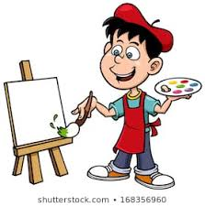

More great books that you may want to try include:

- The Color of Us by Karen Katz (Reading Age all ages)
- All the Colors of the Earth by Sheila Hamanaka (Reading Age 4+)
- Whoever You Are by Mem Fox (Reading Age Birth to 10
- The First Drawing by Mordicai Gerstein (Reading Age 7 to 9)

