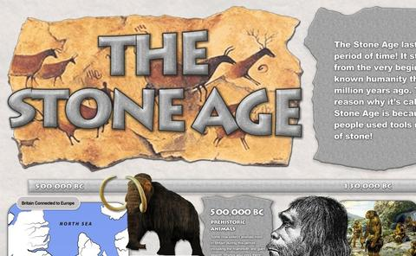

Has today’s visit to the Harris Museum and Art Gallery inspired you to want to find out more about the Stone Age?

Here are some fiction and non- fiction books that you might like to read. You may be able to borrow them from your local Library. Visit https://www.lancashire.gov.uk/libraries-and-archives/libraries/ for more information about your local library services.
Ug : Boy Genius of the Stone Age- Raymond Briggs

A comic style book in which Ug lives with his parents during The Stone Age. Humour is used to show the challenges of prehistoric life including stone blankets, stone cold food, an even colder cave and worst of all hard-stone trousers!

Reading Age 5+

Stone Age Boy – Satoshi Kitamura

This picture book tells the story of a
Boy who falls down a hole and finds
Himself back in time 15,000 years. He
awakens in a prehistoric camp and finds
out about life in a Stone Age Village.

Great read for Year 3 and Year 4.

Stig of the Dump – Clive King and Edward Ardizzone

This is a classic story about a young boy who encounters a strange cave dwelling creature called Stig. Stig and Barney go on a series of fantastic adventures into prehistoric times.

Reading Age 8+

How to Wash a Wooly Mammoth- Michelle Robinson and Kate Hindley

A fun picture book for the mammoth task of pinning down and washing this prehistoric beast.

Reading Age 6+

The Boy with the Bronze Axe- Kathleen Fidler

Set in the Scottish settlement of Skara Brae this story is full of exciting challenges and mysteries.

Reading Age 10+
Wolf Brother – Michelle Paver

This novel takes you back in time 6000 years as twelve year old Tarak and his wolf cub journey through the prehistoric landscape. This is an adventure story.

Reading Age 9+

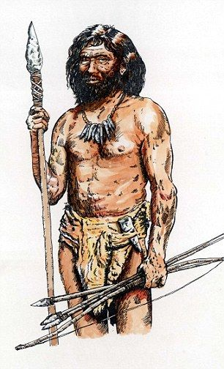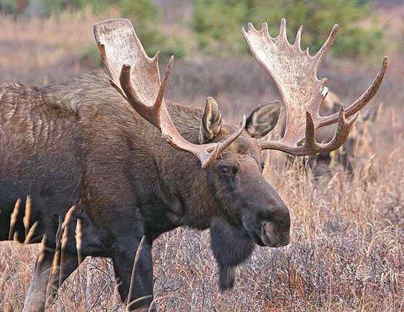
READING IS A GOOD WAY TO FIND OUT MORE
ABOUT US !

The Secrets of Stonehenge – Mick Manning and Brita Granstrom

This is an information book full of images, questions and captions that search the mysteries of Stonhenge.

Reading Age 7+
The History Detective Investigates: Stone Age to Iron Age -Clare Hibbert

An information book that investigates key questions and evidence to build a picture of life in prehistoric times.

Reading Age 8+

More great books that you may want to try include:

- Cave Baby by Julia Donaldson (Reading Age 6+)
- Littlenose Collection The Explorer by John Grant (Reading Age 5 to 7)
- Dave’s Cave by Fran Preston Gannon (Reading Age 5 to 6)
- The First Drawing by Mordicai Gerstein (Reading Age 7 to 9)
- Horrible Histories by Terry Deary and Martin Brown (Reading Age 8 to 12)

