****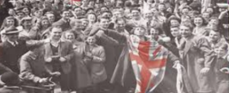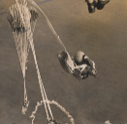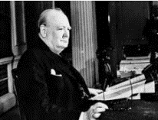

Medals were given by the British Government to those who participated in World War II.

**Design your own medal for a British Soldier to acknowledge their role in the war.**

Think about the shape of the medal and color of the ribbon.

During the war parachutes were used by paratroopers, some were even accompanied by dogs.

**Design and make your own parachute using materials from around the house. Time how long it takes for your parachute to fall to the floor. You could hold it yourself or even ask an adult to help you drop it from a window.**

Many countries were a part of World War II.

**Choose a country and create a fact file about this country.**

Wartime recipe booklet.

**In the booklet there are many recipes you could try and make at home with your family.**

Challenge: think of your favourite meal – write a recipe card and decorate it for somebody else to enjoy as much as you.

No party is a party without some decorations, and this was the case when people held their celebrations at home.

**Design and create your own party decorations. They may include bunting, flags, posters etc.**

.

At 3pm on Friday 8th May 1945, Winston Churchill (the Prime Minster at the time) made an announcement to say the war in Europe had come to an end.

**Practice reading and performing the speech Winston Churchill made on that day – you could even record yourself and send it into school.**

This week we would really like you to get creative and do the best with the activities you have been set. If you cannot make any of the ideas, you could always draw them out and there may be a time you can create them at a later date.

Keep smiling and stay safe. Enjoy the bank holiday celebrating and remember those wonderfully brave people who went to war to protect us and our country! ☺

On VE day street parties took place all over the country to celebrate.

**Design a picnic with all your favourite foods to have at your very own VE Day party.**

.

This week all of your learning tasks build up to celebrate the 75th anniversary of VE Day – marking 75 years since the end of WW2. These activities are for you to enjoy as a family leading up to the celebrations being held on Friday 8th May, which is a Bank Holiday. Please send your photos to your class e-mail address so we can share and enjoy the celebrations together.

Home Learning – VE Day Celebrations.