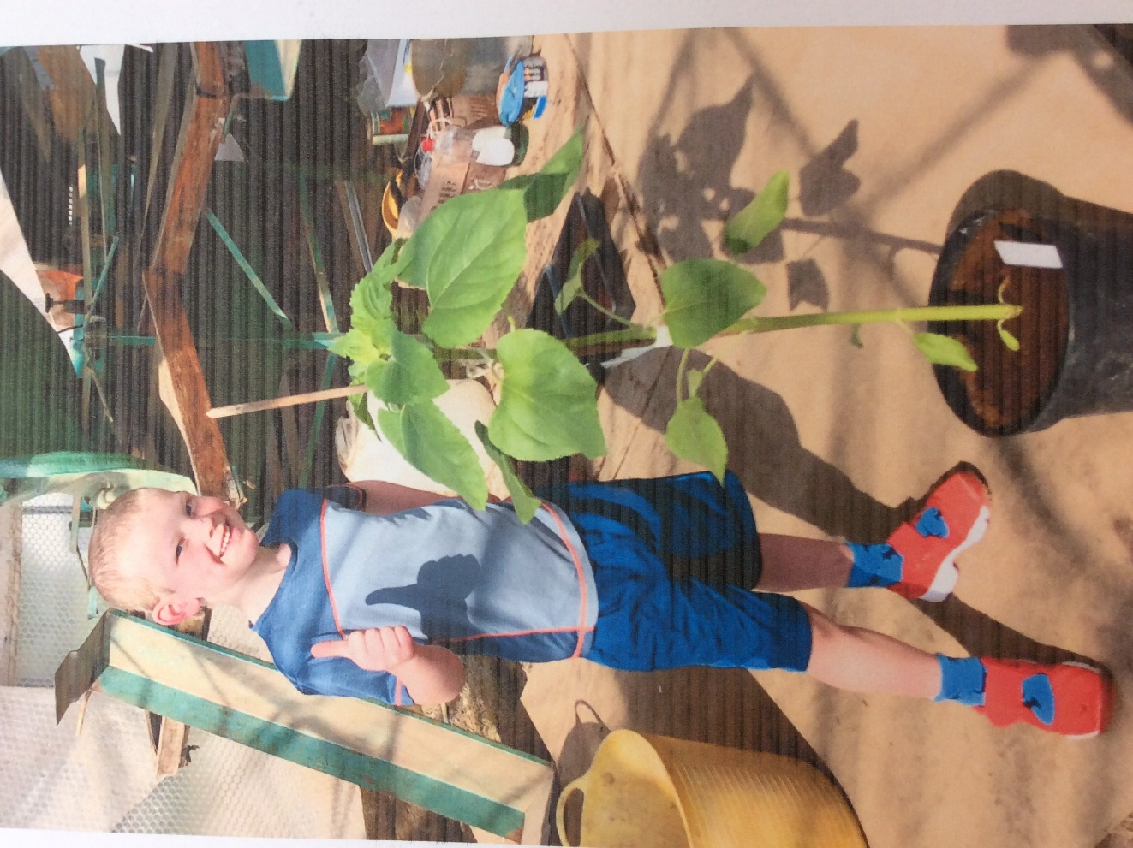

Well done Oliver – your sunflower looks amazing. I wonder how tall it is ?