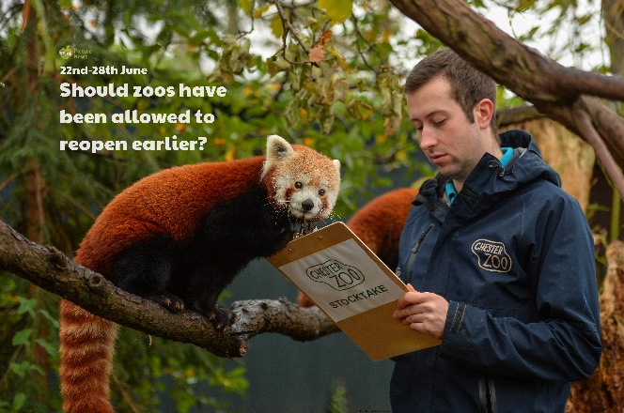

A silhouette is an image of something that is represented as a solid shape or single colour so that we only see the outline. Create some wild animal silhouettes! Use your silhouettes to make a picture or a shadow show, using a torch and a dark room.

Imagine you have your own zoo. Design a map of your zoo. What animals do you have? How much space will they have? Are they inside or outside? Is there anywhere for visitors to get food and drink?

Animals are divided into two main groups: vertebrates (have a backbone), invertebrates (do not have a backbone). Vertebrate are divided into fish, mammals, birds, reptiles and amphibians. Can you find examples of animals that would fit these 5 categories?

Look at a world map. Can you name each continent? Can you find a wild animal that lives on each continent?

Think about a wild animal that you might find in a zoo or your favourite wild animal. Can you find out some more information about it? Where does it live? What does it eat? What does it look like? What size is it? Are there any other interesting facts about your wild animal? Use the information to create a fact file of your wild animal. Don’t forget to include a picture!

Create a poster to advertise Chester Zoo or another zoo that you know. Include a title, catchy slogan, short, snappy sentences, persuasive and emotive language, an offer e.g. free child entry for every three adult tickets purchased, pictures/photographs, information e.g. price, opening times. Perhaps you could send your poster to your chosen zoo? You never know, they might use it!

**Learning from Home**

Use the ideas below, alongside this week’s resource, to support your home learning.