Make a spinning seed!

Have you seen one of these before?
It's a seed from a sycamore tree. Throw them into the air and watch them spin!
You can make your own spinning seed.
1. Cut out a strip of paper.
2. Fold the strip of paper in half.
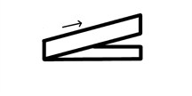
3. Fold the top piece to the right. Flip the strip of paper over and repeat on the other side.
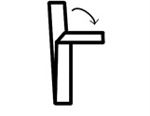
4. Draw a picture on each side of the paper. I drew me with wings! You could draw a bird, an insect or a seed.
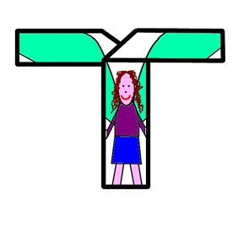
5. Attach a paper clip at the bottom end of the spinning seed, where the first fold is - this is where my legs are in the picture. Throw it in the air! Watch what happens to the spinning seed as it flies.
What's happening?
When the spinning seed falls, air pushes upwards against it. Air also pushes sideways on the arms of the spinning seed. The two arms are getting a push in opposite directions, which makes the seed spin.
This helps sycamore seeds to fall far from the tree so they have plenty of space to grow.

